Wk | Term 4
1 | Buddhist Stories (B1/U5)  Introduction to the stories
2 | Wild Deer Park - No killing
3 | The moon Is Looking At You - No Stealing
4 | The Buddha and Rahula - No lying
5 | The Young Deer that Played Dead - Respect for your teachers
6 | The Buddha Threading the Needle - Help each other
7 | The Crippled Man and the Blind Man - Help each other
8 | The Fish Seller - Make good friends
9 | The Fox and the Otters - Do not be selfish
10 | The Snake’s Head and Tail - Do not fight with each other

Stage One: Term 4 Weekly Overview

VIEN GIAC TEMPLE- AUSTRALIA

Term Four: Stage One, Lesson 1: Buddhist Stories- Introduction to the Stories

Lesson Sequence | Time | Lesson Aim: To introduce the concept of historical stories and to introduce the stories of Buddha.  Resources: My Story worksheet
Chanting | 10 min | - Recite name of Master Buddha-express respect and gratefulness to the Shakyamuni Buddha.  Nam Mô Shakyamuni Buddha (3 times),  - Breathing meditation –connect mind and body to the present.  Next breath in, breath out breath meditation (3 times),  - Chanting Amitabha- peaceful Buddha- lead to complete mindfulness,  followed by Chanting Amitabha student repeat after teacher (3 times)
Lesson Information | 5min | Buddha used stories to help people understand his teachings. He used his words and his life practice to teach people how to live happily.  Today Buddha’s disciples pass on his words and teachings by telling stories that give us examples to learn from.  Teacher will explain- This Term we will be focusing on a story based on Buddha’s teachings each week.
Questioning  and Discussion | 5min | Teacher will ask students if they have been told any of Buddha’s stories.
Student Activity | 5min | Students will have the opportunity to share and retell any stories they know and draw a picture of their story.

VIEN GIAC TEMPLE- AUSTRALIA

Term Four: Stage One, Lesson 1: Buddhist Stories- Introduction to the Stories

My Story

Draw a picture of a story you have been told.

VIEN GIAC TEMPLE- AUSTRALIA

Term Four: Stage One, Lesson 2: Wild Deer Park- No Killing
Lesson Sequence | Time | Lesson Aim: For students to understand that killing animals for fun or sport is unkind and selfish.  Resources: The Deer colouring page
Chanting | 10 min | - Recite name of Master Buddha-express respect and gratefulness to the Shakyamuni Buddha.  Nam Mô Shakyamuni Buddha (3 times),  - Breathing meditation –connect mind and body to the present.  Next breath in, breath out breath meditation (3 times),  - Chanting Amitabha- peaceful Buddha- lead to complete mindfulness,  followed by Chanting Amitabha student repeat after teacher (3 times)
Story | 5min | Wild Deer Park- No Killing  A long time ago there was a beautiful forest. Many deer lived there. One day a king took his men there to hunt. The king shot an arrow and hit a mother deer. She ran away in pain. Later the king found her hiding in some bushes with her baby deer. Even though she was bleeding and had tears in her eyes, she still fed her baby with milk. She soon died. The king felt very sorry. He picked up the baby deer and said to it, “I will now care for you.” He then broke his bow in two. He said, “I’ll never hunt again.” To remember that day, he named the forest Wild Deer Park.  Like people, animals also have feelings. We should not kill them for fun or sport. It is unkind and selfish.
Questioning  and Discussion | 5min | 1. What did the king hit with his arrow?  (A mother deer)  2. Why did the king feel bad?  (The mother deer was in pain and it was feeding it’s baby)  3. Why should we care for animals and not kill them?  (We should not kill animals because they have feelings like people)
Student Activity | 5min | Students will colour in the picture of the deer.
Term Four: Stage One, Activity 2: Wild Deer Park- No killing
VIEN GIAC TEMPLE- AUSTRALIA

Colour in the picture of the deer

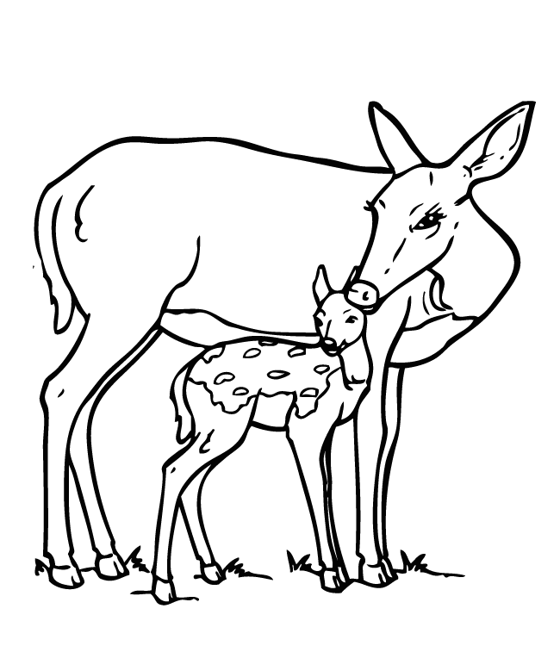No killing
VIEN GIAC TEMPLE- AUSTRALIA
Term Four: Stage One, Lesson 3: The Moon Is Looking At You

Lesson Sequence | Time | Lesson Aim: for students to understand that stealing is not the right thing to do.  Resources: Moon colouring page
Chanting | 10 min | - Recite name of Master Buddha-express respect and gratefulness to the Shakyamuni Buddha.  Nam Mô Shakyamuni Buddha (3 times),  - Breathing meditation –connect mind and body to the present.  Next breath in, breath out breath meditation (3 times),  - Chanting Amitabha- peaceful Buddha- lead to complete mindfulness,  followed by Chanting Amitabha student repeat after teacher (3 times)
Story | 5min | The Moon is Looking at You- No stealing  Once there was a very poor family. They often went to their neighbour’s garden to steal some vegetables.  One night, the father took along his little son into their neighbour’s garden to steal some carrots. While the father was pulling out some carrots, his little boy stood beside him. Suddenly, his son whispered, “Daddy, someone is looking at us.”  The father became afraid. He quickly looked around but he could not see anyone.  “Where? Who?” he asked. The son pointed at the sky, “There, Daddy. It’s the moon. The moon is looking at us.” The father was shocked by what his son said.  He thought that nobody could see what he was doing at night. His son’s words made him feel ashamed. He threw the carrots down and took his son by the hand. They both walked back home in the moonlight. After that he never stole anything again.  If we steal, the truth will always show.
Questioning  and Discussion | 5min | Did anyone see the father and son steal the carrots?  (No one saw them steal)  Why did the father feel bad?  (The father realised that he was doing the wrong thing by taking something that belonged to someone else)
Student Activity | 5min | Students will colour in the picture of the moon.

VIEN GIAC TEMPLE- AUSTRALIA

Term Four: Stage One, Activity 3: The Moon is Looking At You- No Stealing

No stealing

VIEN GIAC TEMPLE- AUSTRALIA

Lesson Sequence | Time | Lesson Aim: We must always be truthful  Resources: The water well colouring sheet
Chanting | 10 min | - Recite name of Master Buddha-express respect and gratefulness to the Shakyamuni Buddha.  Nam Mô Shakyamuni Buddha (3 times),  - Breathing meditation –connect mind and body to the present.  Next breath in, breath out breath meditation (3 times),  - Chanting Amitabha- peaceful Buddha- lead to complete mindfulness,  followed by Chanting Amitabha student repeat after teacher (3 times)
Story | 5min | The Budha and Rahula- No Lying  Rahula, the only son of the Buddha, became a monk. He was the youngest in the Sangha. All the monks loved and spoiled him. Rahula did whatever he liked. Sometimes he told lies just for the fun of it.  One day, Buddha said to Rahula, “Please bring me a basin of water. I want to wash my feet.” He washed his feet in the basin of water and asked Rahula, “Would you drink this water?”  “No, it’s dirty!” Rahula replied. Then Buddha asked Rahula to throw the water away. Buddha told Rahula, “When water gets dirty, no one wants it. It is the same for those who tell lies, no one cares for them anymore.”  Tears of shame come to Rahula’s eyes. He never told another lie.  We should always tell the truth.
Questioning  and Discussion | 5min | What happens to those who tell lies?  (No one cares for them anymore).  Why did Rahula have tears in his eyes?  (He felt bad for telling lies).
Student Activity | 5min | Students will colour in the water well.
Term Four: Stage One, Lesson 4: The Buddha and Rahula- No Lying
VIEN GIAC TEMPLE- AUSTRALIA

Term Four Stage One, Activity 4: The Buddha and Rahula- No Lying

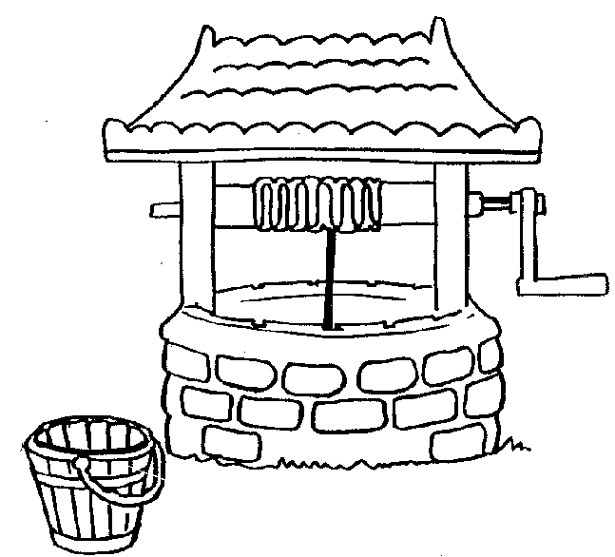

Be Truthful

VIEN GIAC TEMPLE- AUSTRALIA
Term Four: Stage One, Lesson 5: The Young Deer That Played dead- Respect for
Your Teachers
Lesson Sequence | Time | Lesson Aim: To emphasise the importance of respect for teachers.  Resources: Respect for your teachers worksheet.
Chanting | 10 min | - Recite name of Master Buddha-express respect and gratefulness to the Shakyamuni Buddha.  Nam Mô Shakyamuni Buddha (3 times),  - Breathing meditation –connect mind and body to the present.  Next breath in, breath out breath meditation (3 times),  - Chanting Amitabha- peaceful Buddha- lead to complete mindfulness,  followed by Chanting Amitabha student repeat after teacher (3 times)
Story | 10min | The Young Deer That Played dead- Respect for  Your Teachers  A wise deer taught all the young deer how to escape from the hunters. One of them was a very good pupil. He was never bad in class. He also thanked the teacher after every lesson.  One day, this young deer was caught in a trap. The others ran away in fright. They ran to tell his mother. She cried when she heard about this.  The teacher comforted her, “Don’t worry. Your son is such a good pupil, he will come back safely.”  As he was caught in the trap, the young deer remembered what the teacher had taught him. He pretended to be dead by sticking out his tongue and lying still. This made the hunter believe that the deer was really dead.  When the hunter was preparing to cook the deer, it jumped up and ran away like the wind. His friends were so happy to see him back. They thanked the wise teacher for teaching him so well.  Being a good pupil brings great rewards.
Questioning  and Discussion | 5min | How can you show respect for your teachers?  (Be a good listener, follow instructions and be thankful).
Student Activity | 5min | Colour in the respect for teachers colouring page.

VIEN GIAC TEMPLE- AUSTRALIA
Term Four: Stage One, Activity 5: The Young Deer That Played dead- Respect for
Your Teachers

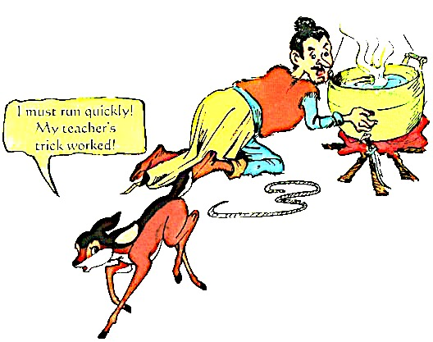
Respect Your Teachers

VIEN GIAC TEMPLE- AUSTRALIA

Lesson Sequence | Time | Lesson Aim: Students will understand that help each other will benefit all.  Resources: Activity 6 worksheet- Help Each Other
Chanting | 10 min | - Recite name of Master Buddha-express respect and gratefulness to the Shakyamuni Buddha.  Nam Mô Shakyamuni Buddha (3 times),  - Breathing meditation –connect mind and body to the present.  Next breath in, breath out breath meditation (3 times),  - Chanting Amitabha- peaceful Buddha- lead to complete mindfulness,  followed by Chanting Amitabha student repeat after teacher (3 times)
Story | 5min | The Buddha Threading the Needle- Help Each Other  Anuruddha was a very good pupil, but he was blind. He did not feel sorry for himself because he was blind and kept up with his practice.  One day, he felt a hole in his robe. He tried to mend it, but found it very difficult. He could not even thread the needle. The Buddha came to his room to thread the needle for him. “Who is threading the needle for me?” Anuruddha asked.  “It is the Buddha,” the Buddha replied while he was mending the robe. Anuruddha felt really happy and was moved to tears.  Always help those who are in need.
Questioning  and Discussion | 5min | Who has helped someone before?  How do people feel when you help them?  How do you feel when you help someone?
Student Activity | 5min | Students will draw and label a picture of themselves helping someone. They will write a sentence about their picture.

Term Four: Stage One, Lesson 6: The Buddha Threading The Needle- Help Each Other

VIEN GIAC TEMPLE- AUSTRALIA

Term Four: Stage One, Activity 6: Help Each Other

Draw a picture of yourself helping someone and complete the sentence.

I am helping _________________________
___________________________________ .

VIEN GIAC TEMPLE- AUSTRALIA

Term Four: Stage One, Lesson 7: The Crippled man and the Blind Man- Help Each Other

Lesson Sequence | Time | Lesson Aim: Students will understand that helping each other will benefit all.
Chanting | 10 min | - Recite name of Master Buddha-express respect and gratefulness to the Shakyamuni Buddha.  Nam Mô Shakyamuni Buddha (3 times),  - Breathing meditation –connect mind and body to the present.  Next breath in, breath out breath meditation (3 times),  - Chanting Amitabha- peaceful Buddha- lead to complete mindfulness,  followed by Chanting Amitabha student repeat after teacher (3 times)
Story | 10min | The Crippled man and the Blind Man- Help Each Other  A crippled man and a blind man were left alone in a house. A fire broke out. Both were very scared. The blind man could not see the way out. The crippled man could not walk to the way out.  They decided to help each other. The blind man carried the crippled man on his back.  The crippled man told the blind man where to go. Together, they got out of the burning house.  If we help each other, we will all win.
Questioning  and Discussion | 5min | How did the blind man and the cripple man help each other?  (They each shared their strength and skill to help the other person).
Student Activity | 5min | - Students will practise helping each other.  - Place children in pairs.  - One person is to close their eyes and the other person is to guide them around the room.

VIEN GIAC TEMPLE- AUSTRALIA

Term Four: Stage One, Lesson 8: The Fish Seller- Make Good Friends
Lesson Sequence | Time | Lesson Aim: Students will learn to make good decisions when choosing friends.  Resources: Activity 8- Make Good Friends
Chanting | 10 min | - Recite name of Master Buddha-express respect and gratefulness to the Shakyamuni Buddha.  Nam Mô Shakyamuni Buddha (3 times),  - Breathing meditation –connect mind and body to the present.  Next breath in, breath out breath meditation (3 times),  - Chanting Amitabha- peaceful Buddha- lead to complete mindfulness,  followed by Chanting Amitabha student repeat after teacher (3 times)
Story | 5min | The Fish Seller- Make Good Friends  The Buddha and Ananda were begging in a city. They passed a fish seller. The Buddha said, “Ananda, touch the rope where the fish are hanging and smell your fingers.”  Ananda did this and said, “It smells awful!” The Buddha said, “This is the same with making friends, if you mix with bad people, you will become bad. This is like the smell from the rope in the fish market.”  Next, they passed a spice shop. The Buddha said, “Ananda, touch the spice wrapper and then smell your fingers.” Ananda did this and said, “My fingers smell very nice.” The Buddha said, “This is the same with making friends. If you mix with good people, you will be a good person. This is like the nice smell you got from the spice wrappers.”  If you mix with good and honest people, you will be a good person.  If you mix with lazy and bad people, you will be a bad person.
Questioning  and Discussion | 5min | What happens when you make good friends?  (You will become good like them).
Student Activity | 10min | - Students will draw themselves playing with a good friend.
VIEN GIAC TEMPLE- AUSTRALIA

Term Four: Stage One, Activity 8: Make Good Friends
Draw a picture yourself playing with a good friend
Term Four: Stage One, Lesson 9: The Fox and The Otters- Do Not Be Selfish
VIEN GIAC TEMPLE- AUSTRALIA

I am playing with ____________________ .

Lesson Sequence | Time | Lesson Aim: To be grateful for the food we have.  Resources: Being grateful worksheet.
Chanting | 10 min | - Recite name of Master Buddha-express respect and gratefulness to the Shakyamuni Buddha.  Nam Mô Shakyamuni Buddha (3 times),  - Breathing meditation –connect mind and body to the present.  Next breath in, breath out breath meditation (3 times),  - Chanting Amitabha- peaceful Buddha- lead to complete mindfulness,  followed by Chanting Amitabha student repeat after teacher (3 times)
Story | 5min | The Fox and The Otters- Do Not Be Selfish  A fox’s wife wanted to eat some fresh fish. The fox tried to find some fish for her near the river. He saw two otters at the river dragging along a big fish. Both wanted the best parts of the fish. The fox watched them for a short time. Then he went up to ask if he could divide the fish for them. The otters were delighted.  The fox divided the fish into three pieces. He gave the head to one otter and the tail to the other. While the otters were thinking how the fox would divide the best part of the fish, the fox ran away with it. The otters had only themselves to blame for being so selfish.  Do not be selfish, share with others.  An otter is an animal that eats fish.
Questioning  and Discussion | 5min | What did the otters do wrong?  (They were fighting over the food).  Teacher will- have a discussion about the importance of being grateful for your food.
Student Activity | 10min | Teacher will write the word grateful on the board to assist the students in completing the sentence on the worksheet.

VIEN GIAC TEMPLE- AUSTRALIA

Term Four: Stage One, Activity 9: The Fox and The Otters- Be Grateful

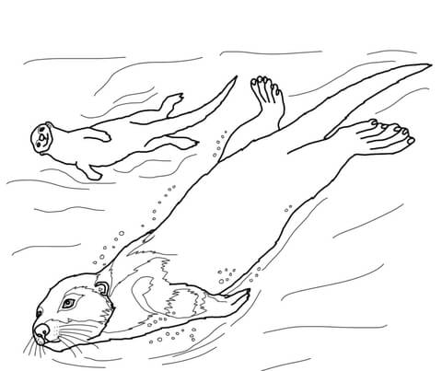
VIEN GIAC TEMPLE- AUSTRALIA

Be _________________ for the food you have.

Term Four: Stage One, Lesson 10: The Snakes Head and Tail
Lesson Sequence | Time | Lesson Aim: Students will understand that we should work together.  Resources: The Snakes and Tail worksheet
Chanting | 10 min | - Recite name of Master Buddha-express respect and gratefulness to the Shakyamuni Buddha.  Nam Mô Shakyamuni Buddha (3 times),  - Breathing meditation –connect mind and body to the present.  Next breath in, breath out breath meditation (3 times),  - Chanting Amitabha- peaceful Buddha- lead to complete mindfulness,  followed by Chanting Amitabha student repeat after teacher (3 times)
Lesson Information | 5min | The Snakes Head and Tail  The snake’s tail had a fight with its head. The tail said, “You have led me for so long. Now it’s time for me to lead you”.  The head said, “I should be the leader, I have eyes and a mouth”.  The tail said, “You need me to move, without me, you can’t go anywhere”.  Then the tail grabbed a tree branch and would not let go. The snake’s head gave up and let the tail be the leader. The head did not want to help the tail. The tail could not see where it was going. Then, it fell into a fire pit. The snake was burnt to death.  It hurts both sides when you argue.
Questioning  and Discussion | 5min | What should the snake’s head and tail have done?  (They should have worked together)
Student Activity | 10min | Students will complete The Snakes and Tail worksheet

VIEN GIAC TEMPLE- AUSTRALIA

Term Four: Stage One, Activity 10: The Snakes Head and Tail

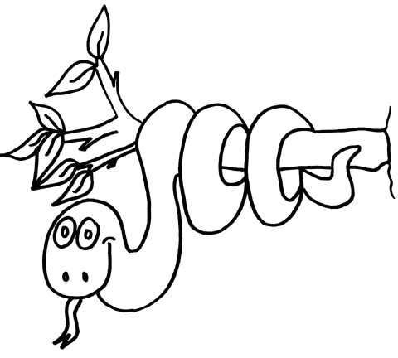

Work together
VIEN GIAC TEMPLE- AUSTRALIA

