TERM FOUR: STAGE THREE WEEKLY OVERVIEW

Wk | Term 4
1 | Lessons from Buddhism  Introduction – The Paramitas
2 | The Buffalo and the Monkey  - Patience( DB/JP8)
3 | Prince Five Weapons (DB/JP13)
4 | Have My Efforts Been Worthwhile?  - Effort, Persistence (DB/JP14)
5 | The Good Doctor  - Wisdom (DB/JP16)
6 | The Drunken Beetle  - Wisdom, right action (DB/JP18)
7 | A Bush Turkey and a False-Friend Falcon  - Integrity, Kindness, Compassion (DB/MV5)
8 | Change in Myself  - Awareness of Impermanence (DB/CI1)
9 | Cycles of Change  - Change is natural (DB/CI3)
10 | Review

VIEN GIAC TEMPLE- AUSTRALIA

Term Four: Stage 3 Lesson 1: Introduction – The Paramitas
Lesson Sequence | Time | Lesson Aim: To identify examples of virtuous and moral actions in the story and to understand more of the wisdom of acting according to these.  Resources: Have a copy of the Wisdom Cards for each student.
Chanting | 10min | - Recite name of Master Buddha-express respect and gratefulness to the Shakyamuni Buddha.  Nam Mô Shakyamuni Buddha (3 times),  - Breathing meditation –connect mind and body to the present.  Next breath in, breath out breath meditation (10 times)
Story | 5min | Introduction to the Paramitas (virtue and skilful action) through the Jataka Tales  In Buddhism, virtues are called Paramitas or perfections. Skilful action and morals arise from the practice of these virtues, and lead to moral precepts where Buddhists take vows to avoid harmful conduct. The Paramitas are positive virtues that guide us to a path of morality. This path could lead us to contentment, happiness and an enlightened mind. During this Term, we will discuss the Paramitas through the Jataka Tales: each tale outlines more than one Paramita and as well as a model of skilful behaviour.  The Paramitas are-  Loving kindness (Pali: metta) can also be compassion. All positive and moral conduct is a form of kindness to self and others.  Giving or generosity (Pali: dana) does not always mean material aid. Giving can be in the form of good conduct, such as care and patience, and wishing benefit to others.  Equal love or joy with others is also related to equanimity, being even tempered and learning to love all creatures as dearly as one-self.  Renunciation or finding the Middle Way by not going to extremes and not holding tightly to fixed ideas, objects and people.  Patience is about remaining calm and good tempered in annoying and difficult situations. It is a form of being kind to oneself and to others.  Effort is maintaining energy to learn and do things well, but with kindly and mindful application according to the Middle Way.  Wisdom is apparent in all the Buddha’s teachings. It is about understanding the way things are and the way the world works. It is based on interconnectedness and cause and effect relationships. Children are forming their senses of self and identity and it is not wise to introduce them to the concepts of ‘non-self’.  Honesty requires courage to seek truth, uphold what is true and to value truth and honesty in personal conduct, with others and society.  Perseverance is the will to keep going, to have persistence and not to give up.  Right action is moral conduct by avoiding harmful actions. It can also be viewed as forms of kindness to oneself because harmful results from actions are also avoided. For lay Buddhists the first rule, or precept, is to avoid killing, and then to avoid lying and stealing. The fourth precept is interpreted for children here as being a loyal and faithful friend, and avoiding intoxicants can also be linked to avoiding extreme behaviours and the Middle Way.
Question & Discussion | 10min | Ask students if they are familiar with the Paramitas.  Ask students to think of situations where they have been able to use these Parimatas and share with the class.
Student Activity | 5min | Students will colour in three Paramitas on their Wisdom Cards, which they wish to improve in themselves. Then they will share with a partner why they chose these Paramitas. Teacher will collect the cards to use for final lesson of Term Four, to be used for reflection.
Term Four: Stage 3 Activity 1: Introduction – The Paramitas
VIEN GIAC TEMPLE- AUSTRALIA
Wisdom Cards Name______________________________

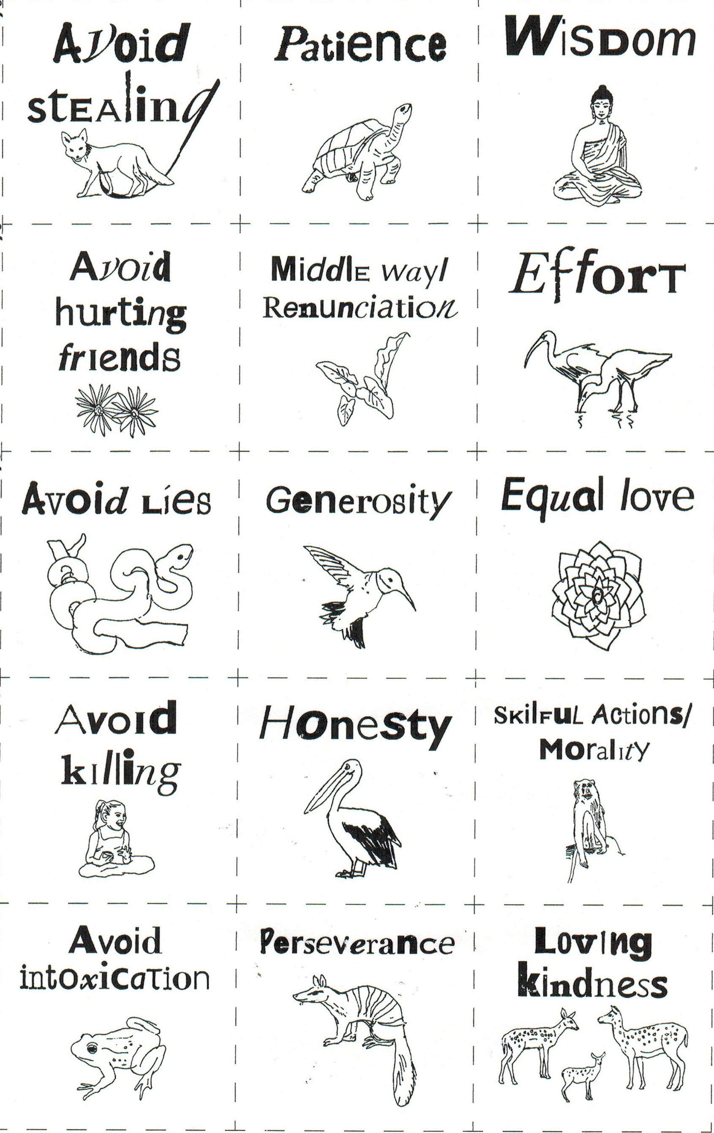
VIEN GIAC TEMPLE AUSTRALIA

Term Four: Stage 3 Lesson 2: The Buffalo and The Monkey- Patience
VIEN GIAC TEMPLE- AUSTRALIA
Lesson Sequence | Time | Lesson Aim: For students to recognise patience.  Resources: Self-reflection worksheet.
Chanting | 10min | - Recite name of Master Buddha-express respect and gratefulness to the Shakyamuni Buddha.  Nam Mô Shakyamuni Buddha (3 times),  - Breathing meditation –connect mind and body to the present.  Next breath in, breath out breath meditation (10 times)
Story | 5min | The Buffalo and The Monkey- Patience  A long time ago in ancient India there was a buffalo. He was large and strong and had two long, sharp horns. He roamed freely around the Himalayas led a very contented life. That was, except for when he had his lunch. The buffalo liked to have his lunch under a very lovely mango tree on top of a peak with a beautiful view.  In the tree lived a monkey who was a real pest. Each day when the buffalo was eating his lunch the monkey would swing down from the tree to annoy the buffalo. The monkey would slide down his horns, swing from his tail.  Each day the buffalo would beg the monkey to stop his carrying on, but of course the monkey refused. He was having the best fun. The buffalo would plead with the monkey, “Please my friend, stop this nonsense. No good will come of it.”  A little bird who lived in the mango tree saw the monkey carrying on everyday and didn’t know how the buffalo could stand it. She asked the buffalo: Why do you patiently put up with this pest? Why don’t you crush him, and allow yourself rest?  “If I get angry with the monkey I will end up even more bothered than I am now,” explained the buffalo, “That isn’t rest.” “Besides, my guess is that this monkey will carry on with other animals the way he does with me. I will put up with his nonsense and maybe save him from coming to harm, and save me from doing some harmful deed that I will live to regret later.”  Then the buffalo continued in verse:  If he treats others as he treats me They will destroy him, sadly, but from giving harm I am free.  A few days later the buffalo chose to eat lunch under another tree and a savage buffalo came to eat lunch under the mango tree.  Down swung the monkey from the tree and slid up and down the horns, swung in circles from the buffalo’s tail.  The savage buffalo shook the monkey off his back and trampled him under his hoofs.
Question  and Discussion | 10min | The buffalo had a lot to put up with. He gave two reasons why he would not attack the monkey. What are they?  Answer: 1. If the buffalo gets angry he will be doing himself harm.  2. If the buffalo allows the monkey to annoy him, he will save the monkey  from harming others and being harmed by them.
Student Activity | 5min | Students will reflect on what they could do if someone is annoying them.

Term Four: Stage 3 Activity 2: The Buffalo and The Monkey- Patience
VIEN GIAC TEMPLE- AUSTRALIA

Self – Reflection: Patience

Draw an incident where someone is annoying you.

How can you politely ask them to stop being annoying?
___________________________________________________________________________________________________________________________________________________________________________________________________________________________________________________________________________________________________________________________________________________________________

Term Four: Stage 3 Lesson 3: The Prince Five Weapons- Effort and Perseverance
Lesson Sequence | Time | Lesson Aim: To teach that using good qualities and skills can help them win a competition.  Resources: Worksheet: Sports, Skills and Qualities.
Chanting | 10min | - Recite name of Master Buddha-express respect and gratefulness to the Shakyamuni Buddha.  Nam Mô Shakyamuni Buddha (3 times),  - Breathing meditation –connect mind and body to the present.  Next breath in, breath out breath meditation (10 times)
Story | 10min | The Prince Five Weapons- Effort and Perseverance  A long time ago in ancient India the future Buddha was born. On the day he was to be named, his parents gave food and gifts to eight hundred wise and educated folk, and asked what the child’s destiny would be. They predicted a glorious life where the child would become a great king, and famous throughout the world for his mastery of five weapons. So his parents named him Prince Five Weapons.  When the prince turned sixteen he was sent to study with a world famous instructor at the best school in India. He was a good student, and when it was time for him to leave, his instructor gave him a present, a set of five weapons. On his way back home he came to a forest haunted by an ogre known as Hairy Grip. At the entrance to the forest, some men met the prince and tried to stop him from going into the forest, they told him of the ogre who kills everyone he meets. But the confident prince went into the forest until he came across the ogre.  The ogre was as tall as a palm-tree, with an over-sized head and huge bulging eyes, two large tusks and the beak of a hawk. His belly had ugly purple spots and the palms of his hands and the soles of his feet were bluish black!  “Go away, or I will eat you!” cried the ogre. “Ogre,” the Prince replied, “I am Prince Five Weapons and I can defend myself. I warn you not to come near me. I will slay you where you stand with a poisoned arrow,” Said the prince. Defiantly he fitted his bow with an arrow dipped in the deadliest poison and shot it at the ogre. But it stuck to the monster’s shaggy coat of hair, not even piercing his skin. Then he shot another arrow, and another. He shot fifty poisoned arrows and all of them just stuck to the ogre’s hair.  Then the ogre shook off the arrows and came at the Prince. The Prince was not going to give in, and drew his sword and struck out at the ogre. But like the arrows, his sword did not go past the ogre’s fur. Next the Prince hurled his spear, and that also stuck to the ogre’s hairy fur. Next the Prince hurled his spear, and that also stuck to the ogre’s hairy body.  Not giving up, Prince Five Weapons struck the ogre with his club, but that got stuck in the thick hair under his armpit. Still, Prince Five Weapons did not want to give up. “Ogre, you obviously haven’t heard of me before. I’m Prince Five Weapons! When I came into this forest, I put my trust in my bow and other weapons. Now I put my trust in myself! I will strike you a blow that will crush you into the dust!” The ogre did not move.

VIEN GIAC TEMPLE - AUSTRALIA

Lesson Sequence | Time | Lesson Aim: For students to appreciate that effort and perseverance will help them realize their full potential
Story |  | The Prince gave a massive blow with his right fist, and his right fist stuck on the ogre’s hair. Then he gave a powerful left hook, which stuck his fist in the ogre’s hair. He followed swiftly with a right- foot kick and a sharp jab with his left foot, leaving Prince Five Weapons stuck to the ogre’s hairy back by all four limbs. The Prince fully understood now why the ogre’s name was Hairy Grip. Still Prince Five Weapons was no quitter. Gathering his strength once again Prince Five Weapons shouted, “I will crush you into dust!” and head-butted the ogre. Now his head, too, was firmly stuck to Hairy Grip Ogre, yet the Prince Five Weapons would not be defeated.  As the Prince dangled from this ogre, the monster got to thinking, “This is a brave man among men, a real hero. Though he is caught in the clutches of an ogre like me, he does not tremble. Never, since I first took up slaying travellers upon this road, have I seen a man to equal him. How come he is not frightened?”  Not daring to eat the Prince just then he asked, “How is it, young man, that you have no fear?” “Why should I?” the Prince replied with calm confidence, “I have a sword inside my body which you will never digest if you eat me. It will chop your insides to mincemeat, and my death will involve yours too. Therefore I have no fear.” By this the Prince meant the Sword of Wisdom, which shone within him. This made the ogre think, “This man is talking the truth and nothing but the truth. I could not digest a man even the size of a pea of this young hero. I’ll let him go,” and so, in fear of his life, Hairy Grip carefully dislodged the Prince, limb by limb, from his hairy grip. “I will not eat you. Go home to your family, your friends and your country. Make them happy. Don’t worry about me. I will think of something else to do....I suppose...”  “Yes, ogre, I will go,” answered the Prince, “but I want you to know that it was your deeds in the past that caused you to become a murderous, flesh- eating ogre, and if you continue like this, you will go from horror to horror.  “I am giving you something to think about,” the Prince continued, “Know that to destroy life will create for you a living hell and you will become one of the most wretched creatures. Even if you lived as a human, then these cruel actions will cut short the days of your life.”  By this blunt explanation of the consequences of virtuous and non-virtuous actions the monster did not want to create any more unhappiness for him or others.  Prince Five Weapons made him a guardian fairy of the forest, and proceeded home, letting it be known that the forest was now safe to enter. At the end of the story the Buddha recited a verse:  When no attachment hampers heart or mind,  When rightness is practised,  Peace you find,  By doing this you gain the victory and all limitations utterly destroy.  The Buddha then explained, “Angulimala was the ogre of those days, and he was the Prince Five Weapons.”
Question  and Discussion | 5min | How did Prince Five Weapons overcome his limitations?  Answer: The Prince used his inner strength of wisdom.  What was right about his actions?  Answer: The Prince was not attached to his weapons; he was righteous by using his wisdom to save himself and the Ogre.
Student activity | 5min | Place students in small groups, have them reflect on and retell the story in to each other in their own words.
VIEN GIAC TEMPLE - AUSTRALIA
Term Four: Stage 3 Lesson 4: Have My Efforts Been Worthwhile- Effort and Persistence

Lesson Sequence | Time | Lesson Aim: To reflect on past achievements which were achieved with effort and persistence.  Resources: Lesson 4 activity sheet: Effort and Persistence
Chanting | 10min | - Recite name of Master Buddha-express respect and gratefulness to the Shakyamuni Buddha.  Nam Mô Shakyamuni Buddha (3 times),  - Breathing meditation –connect mind and body to the present.  Next breath in, breath out breath meditation (10 times)
Story | 5min | Reflection on previous story- Prince of Five Weapons.  Retell the story Prince of Five Weapons with the students, give them the opportunity to help with the retelling.  Remind the students that the Prince was persistent; he used all of his weapons without giving up. When they all failed, he used his strongest weapon of all, which was his inner strength of wisdom.
Question and discussion | 10min | Ask the class who can ride a bicycle confidently?  How long did that take? Who found it easy?  Who found learning to ride difficult?  Ask individual students about how they felt while trying to learn?  Did he/she feel pain or tiredness? Did he/she feel like giving up?  What made him/her continue?  At the end, after being persistent, how did the student feel?
Student Activity | 5min | Students will reflect on a skill they have learned and explain why it is useful to them.  Examples:  Reading a book, cooking, exercising, gardening.

VIEN GIAC TEMPLE - AUSTRALIA

Term Four: Stage 3 Activity 4: Have My Efforts Been Worthwhile-

Effort and Persistence
How is this skill useful to you?
_________________________________________________________________________________________________________________________________________________________________________________________________________________________________________________________________________
VIEN GIAC TEMPLE - AUSTRALIA
Draw yourself performing a skill where you used persistence and effort to learn.
Term Four: Stage 3 Lesson 5: The Good Doctor - Wisdom
VIEN GIAC TEMPLE - AUSTRALIA
Lesson Sequence | Time | Lesson Aim: To explore the nature of wisdom  Resources: Activity 5- Wisdom worksheet
Chanting | 10min | - Recite name of Master Buddha-express respect and gratefulness to the Shakyamuni Buddha.  Nam Mô Shakyamuni Buddha (3 times),  - Breathing meditation –connect mind and body to the present.  Next breath in, breath out breath meditation (10 times)
Story | 5min | The Good Doctor  A long time ago in a town in ancient India lived a doctor who was known to be very wise.  One day a mother and child went to the public baths for a wash. The mother bathed her baby, and then sat her on the bank while she took her turn to wash. At that time a Yakshini, a cannibal witch, came by and saw the child. “You my little precious look delicious,” she whispered.  Then she spoke to the mother in a friendly voice, “Mother, what a sweet child. May I play with her while you wash?” As soon as the mother agreed the Yakshini grabbed the child in her arms and ran off with her. The mother was shocked. She jumped from the pool and ran after the witch. “Where are you taking my child? Come back you wicked witch!” “Mind your language,” the witch said, “This is my child. Now go away!” They started a loud argument and a crowd gathered.  The Good Doctor, who was well respected in the town, came out of his house to see what the fuss was about. He listened to the women and asked if they would accept his decision.  They agreed. Then the doctor drew a line on the ground and instructed the women to each take a hand of the child. “Whoever pulls the child over the line can claim the child!” he announced.  The women pulled; one pulled one way, the other the other way. The little child screamed with pain. The mother could not bear to see her child suffer. She let go and sobbed as if her heart was breaking. “See, the kid is mine!” the Yakshini said happily.  “Just a minute,” said the doctor talking to the, “Who loves a baby the most? The one who has given birth, or the one who has not?” “The one who has given birth!” the crowd agreed. “And who would suffer if her child is suffering?” “The mother,” the crowd said. “So who would let the child go?” “The mother!” “And who is the thief?” “This revolting creature here,” they yelled.  The doctor, who was later to become the Buddha, turned to the Yakshini and asked, “Why did you do such a thing?” “Because I wanted to eat her!” was her defiant reply.  “Oh foolish woman,” the doctor replied, “From your former deeds you have been born a cannibal, and now you keep on behaving in ways that still bring no good. You must promise to be honest and not harm another creature if you are to go.” All the people were moved by the doctor’s wisdom and felt confident that what he had said was true.
Question and discussion | 5min | Who do we consider to be a wise person in our family?  Grandparents? Parents? Teachers? What makes them wise?  Possible answers: They are elderly, have life experience, have been trained, have an education.
Student Activity | 5min | Students will reflect on a person who they think is wise and what makes them a wise person.

Term Four: Stage 3 Activity 5: The Good Doctor - Wisdom

Wisdom
VIEN GIAC TEMPLE - AUSTRALIA

My wise person is ___________________________________________.

I think they are wise because ________________________________________.

They can teach me _____________________________________________________________________________________________________________________________________________________________________________________________________________________________________________________________________________________________________________________________________.
Draw a person in your family who has wisdom.
Term Four: Stage 3 Lesson 6: The Drunken Beetle- Wisdom and Right Action
Lesson Sequence | Time | Lesson Aim: For students to consider various effects of intoxication.  Resources: Activity 6 Worksheet: The Elephant’s Thoughts.
Chanting | 10min | - Recite name of Master Buddha-express respect and gratefulness to the Shakyamuni Buddha.  Nam Mô Shakyamuni Buddha (3 times),  - Breathing meditation –connect mind and body to the present.  Next breath in, breath out breath meditation (10 times)
Story | 5min | (Note: A Dung Beetle is an insect who collects dung and they stink).  The Drunken Beetle  There was once a little Dung- Beetle. One day he was very thirsty and saw a glass of wine that was left outside on the ground. He knew that it was not water, but thought he would drink it anyway.  The beetle became quite drunk, he staggered back to the pile of dung that was his home. As he crawled into the pile of mud it collapsed a little. “The world crumbles under my feet,” he shouted, “I am a champion!’ The beetle thought he was king of the world and completely invincible.  At that time an elephant came by. He smelled a mixture of dung and alcohol and jumped back from the sickly smell. The beetle staggered to the top of the pile od dung. “Elephant, you are weak. I saw you jump back from me. Come on, let’s fight,” he yelled.  Then standing up on his four back legs and shaping up to the elephant with his front legs he continued in verse:  We are well matched! You and I are heroes. So go on, land your punches and then you can cop my blows.  The elephant was not amused. He thought the beetle was silly and he did not fight with him. The elephant walked away.  The elephant thought to himself in verse:  That beetle must have been drunk, He was talking a lot of nonsense,  Wanting to fight he was out of his head So I walked away instead!
Question and discussion | 5min | What are some other effects of intoxication?  Why did Buddha recommend that people avoid getting drunk or intoxicated?
Student Activity | 5min | Students will reflect on why the elephant didn’t fight with the beetle. They will write down their interpretation of what the elephant was thinking.  Answers: The elephant was patient and he put up with the beetle so that the beetle doesn’t start a fight with others; therefor he was protecting the beetle from harm. He knew that the beetle wasn’t in his right mind because he was intoxicated.

VIEN GIAC TEMPLE - AUSTRALIA
Term Four: Stage 3 Activity 6: The Drunken Beetle- Wisdom and Right Action

The elephant’s Thoughts

VIEN GIAC TEMPLE - AUSTRALIA

Why didn’t the elephant fight with the beetle?
Write down his thoughts.

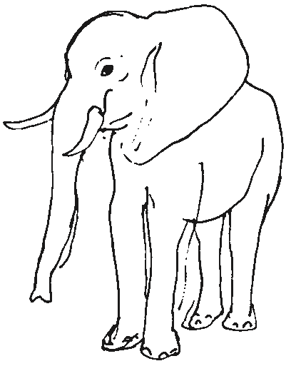

______________________________________________________________________________________________________________________________________________________________________________________________________________________________________________________________________________________________________________________________________________________________________________________________________

Term Four: Stage 3 Lesson 7: A Bush Turkey and a False Friend Falcon
Lesson Sequence | Time | Lesson Aim: To consider the qualities of a true friend and to show gratitude and kindness towards friends.  Resources: Activity 7 worksheet- A Letter to a Friend.
Chanting | 10min | - Recite name of Master Buddha-express respect and gratefulness to the Shakyamuni Buddha.  Nam Mô Shakyamuni Buddha (3 times),  - Breathing meditation –connect mind and body to the present.  Next breath in, breath out breath meditation (10 times),
Story | 5min | A Bush Turkey and a False Friend Falcon  There once was a bush turkey, he grew up to be the head of his flock. In his area lived a falcon who would circle the skies and swoop to catch a turkey from the flock to eat.  Eventually, all of the turkeys were eaten and only the leader of the flock remained. This turkey would take great care to hide in the bushes so the falcon would not see him from the sky.  The falcon grew frustrated at not being able to catch the bush turkey, so he tried to trick him. The falcon perched on a branch of a tree and called to the turkey, “Dear bush turkey, why do you fear me? I want to be friends with you. Over the hill there is food for both of us. Why don’t we go there and eat together?”  “No way,” replied the bush turkey, “You and I can never be friends, so go away!”  “Come on now,” said the falcon, “I have changed. I am sick of eating bush turkeys. I promise you that I will be a good friend to you.” “I don’t believe you. Now go away!” answered the bush turkey, “You have eaten all my friends so you can never be a friend of mine.”  Then the bush turkey thought about friendship and spoke aloud in verse for all the animals of the forest to hear, he advised them to choose their friends carefully and not to trust those who tell lies.  All the animals clapped and cheered when they heard this verse and the falcon flew away, because nobody wanted to be his friend.
Question and discussion | 5min | Discuss the qualities of what makes a good friend.  Some answers could be: Honesty, kindness, and friendliness.
Student Activity | 5min | Students write a letter to a friend explaining why they are a good friend. Students may give their letter to their friend.

- Integrity, Kindness, Compassion
VIEN GIAC TEMPLE - AUSTRALIA

Term Four: Stage 3 Activity 7: A Bush Turkey and a False Friend Falcon
Write a letter to your friend and tell them why they are a good friend to you.

VIEN GIAC TEMPLE - AUSTRALIA
Dear_____________________,

__________________________________________________________________________________________________________________________________________________________________________________________________________________________________________________________________________________________________________________________________________

From your friend,

_______________
Term Four: Stage 3 Lesson 8: Change in Myself - Awareness and Impermanence

Lesson Sequence | Time | Lesson Aim: To encourage the children to observe change and for them to see that everything is impermanent.  Resources: Activity 8- The Changes in myself worksheet
Chanting | 10min | - Recite name of Master Buddha-express respect and gratefulness to the Shakyamuni Buddha.  Nam Mô Shakyamuni Buddha (3 times),  - Breathing meditation –connect mind and body to the present.  Next breath in, breath out breath meditation (10 times)
Story | 5min | Change in Myself - Awareness and Impermanence  Awareness of the impermanence of all things.  Cycles of Change  External, Environmental Changes  - Ask students if they have noticed any changes in themselves over the week? What about people around them? Have they been sitting with the same classmate for the whole year? Could it be changed next week? In 1 month? In 3 months? In 1 year?  -What about change outside the classroom? Does the tree outside the classroom drop its leaves? Why do some trees drop their leaves, as the season becomes colder?  Internal, Personal Changes  -Explain to the students that our thoughts do not stay the same and that we can change our minds about things. We may think that an activity is fun and then we may stop enjoying that same activity.  - We may enjoy the taste of a certain food and then we may grow not to want to eat it anymore.
Question and discussion | 5min | Ask the students to think about change, whether it can happen suddenly or slowly?  Can we predict when change is going to happen?
Student Activity | 5min | Students will fill in the table about changes in their life and share some of their thoughts.
Term Four: Stage 3 Activity 8: Change in Myself - Awareness and Impermanence
VIEN GIAC TEMPLE - AUSTRALIA

Write down a list of changes you have observed. The first two have been done for you.
Who/What/Where | Before | After
The river | The water was deep. | The water is shallow.
Myself | I was tired. | I now have energy.
Term Four: Stage 3 Lesson 9: Cycles of Change
VIEN GIAC TEMPLE - AUSTRALIA
Lesson Sequence | Time | Lesson Aim: To allow the children to observe change around them and to see that everything is impermanent.  Resources: Activity 9- Changes in a Plant worksheet.
Chanting | 10min | - Recite name of Master Buddha-express respect and gratefulness to the Shakyamuni Buddha.  Nam Mô Shakyamuni Buddha (3 times),  - Breathing meditation –connect mind and body to the present.  Next breath in, breath out breath meditation (10 times)
Lesson | 10min | Cycles of Change  Discuss the main points in the Buddha’s early life, especially recalling the Four Sights. What was Prince Siddhartha’s reaction to these sights?  Briefly retell the story.  The Four Sights  One day, Prince Siddhartha went out into the city with Channa, his chauffer. Soon, they saw an old man leaning on a stick and walking very slowly. His hair and teeth were falling out. Siddhartha was confused. “What’s that?’, he asked. “Old age,” said Channa. “Everyone grows old.” The sight upset the prince.  On the second day they saw a person who was very sick. “What happened?” he asked. “Sickness.” said Channa. “Everyone gets ill some time in their life.”  Siddhartha was shocked, he had never seen an ill person.  On the third day, they went out again and saw something even worse. They saw a dead person. “What’s that” asked Siddhartha?” “ A dead person, everyone has to die,” said Channa.” Siddhartha asked, “Why is there so much suffering? What can I do?”  On the fourth day, they saw a man dressed in simple robes and carrying a bowl.  He looked happy and at peace. This was the fourth sight.
Questions and Discussion | 5min | What things can’t we change?  Answers: (getting old, getting sick and eventually dying)  What things are possible to change?  Answer: (our thoughts)  Is it possible to change our lives for the better?  (Teacher will give examples about changing our thoughts in order for our lives to be better).
Student Activity | 10min | Students will make a flap book, which shows the changes in a plant. They will discuss the changes they observe with a friend.
VIEN GIAC TEMPLE - AUSTRALIA
Term Four: Stage 3 Activity 9: Cycles of Change- Changes in a Plant

- Cut around the outside box.
- Fold along the dotted line to make a flap book.
- Observe the changes in a plant.
- Discuss with a friend.

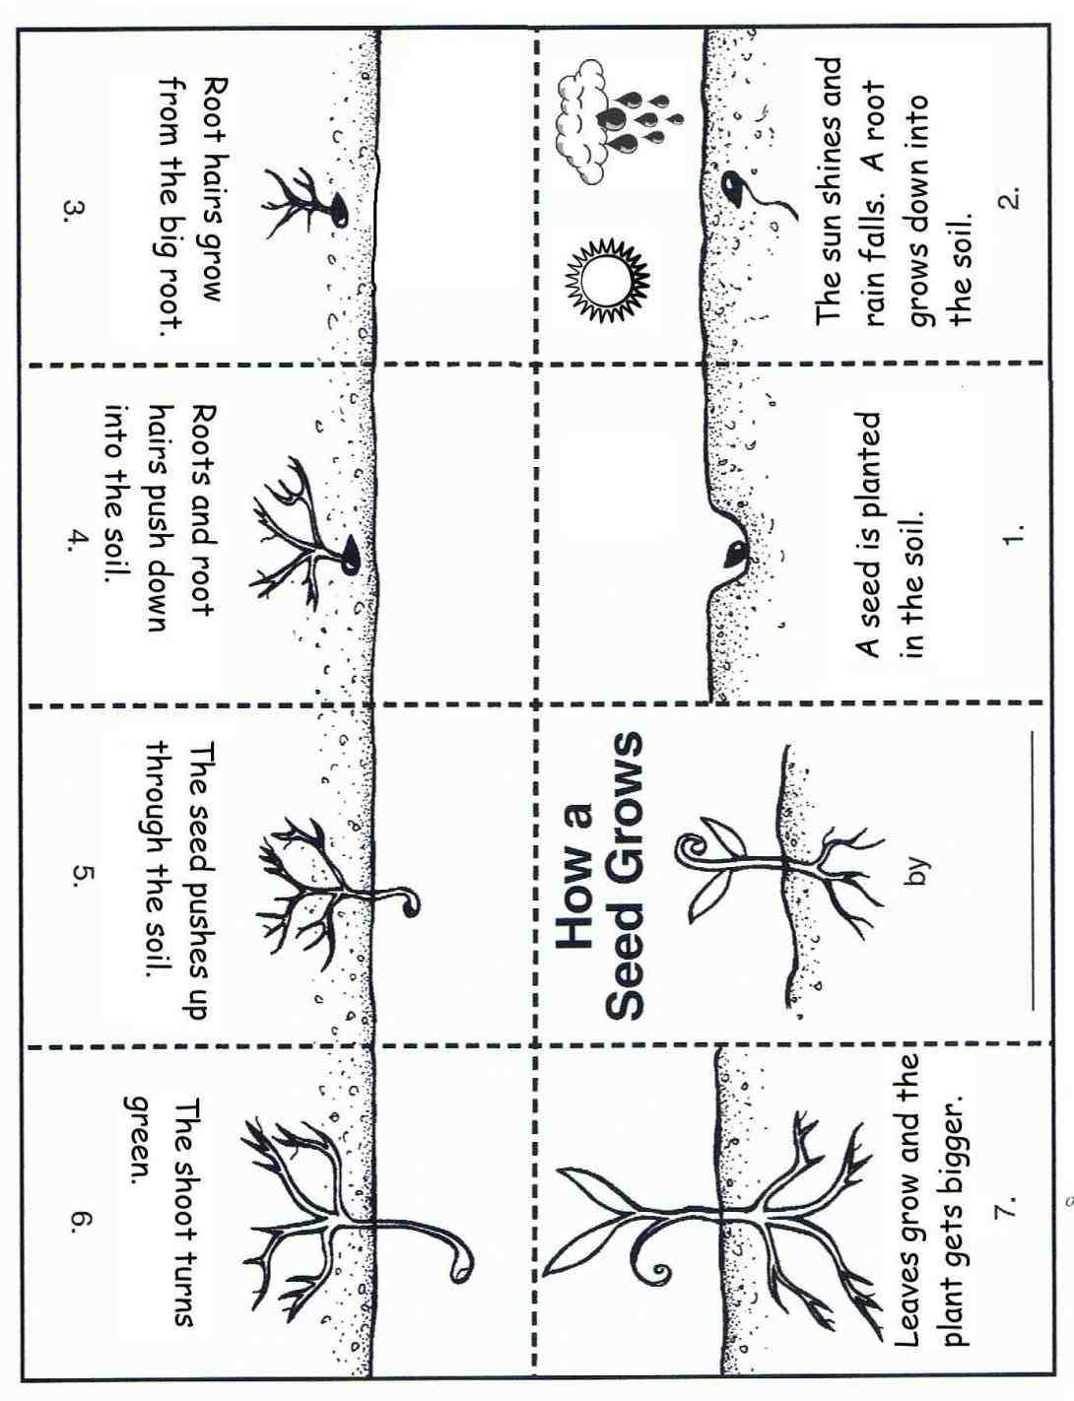
VIEN GIAC TEMPLE - AUSTRALIA
Term Four: Stage 3 Lesson 10: Review
Lesson Sequence | Time | Lesson Aim: To allow the children to observe change around them and to see that everything is impermanent.  Resources: Wisdom cards which students used in Lesson One.
Chanting | 10min | - Recite name of Master Buddha-express respect and gratefulness to the Shakyamuni Buddha.  Nam Mô Shakyamuni Buddha (3 times),  - Breathing meditation –connect mind and body to the present.  Next breath in, breath out breath meditation (10 times)
Lesson | 10min | Review of Lesson One: The Paramitas  The Paramitas are-  Loving kindness (Pali: metta) can also be compassion. All positive and moral conduct is a form of kindness to self and others.  Giving or generosity (Pali: dana) does not always mean material aid. Giving can be in the form of good conduct, such as care and patience, and wishing benefit to others.  Equal love or joy with others is also related to equanimity, being even tempered and learning to love all creatures as dearly as one-self.  Renunciation or finding the Middle Way by not going to extremes and not holding tightly to fixed ideas, objects and people.  Patience is about remaining calm and good tempered in annoying and difficult situations. It is a form of being kind to oneself and to others.  Effort is maintaining energy to learn and do things well, but with kindly and mindful application according to the Middle Way.  Wisdom is apparent in all the Buddha’s teachings. It is about understanding the way things are and the way the world works. It is based on interconnectedness and cause and effect relationships. Children are forming their senses of self and identity and it is not wise to introduce them to the concepts of ‘non-self’.  Honesty requires courage to seek truth, uphold what is true and to value truth and honesty in personal conduct, with others and society.  Perseverance is the will to keep going and not to give up.  Right action is moral conduct by avoiding harmful actions. It can also be viewed as forms of kindness to oneself because harmful results from actions are also avoided. For lay Buddhists the first rule, or precept, is to avoid killing, and then to avoid lying and stealing. The fourth precept is interpreted for children here as being a loyal and faithful friend, and avoiding intoxicants can also be linked to avoiding extreme behaviours and the Middle Way.
Questions and Discussion | 5min | Ask students to recall the Paramatis which they chose to improve on.  Ask students if they were successful on improving themselves.
Student Activity | 10min | Students will have their Wisdom Cards which they used in lesson 1.  They will look at the Paramitas they chose to improve on at the beginning of the Term. They will discuss with a partner what they improved on.
VIEN GIAC TEMPLE - AUSTRALIA

Term Four Stage 3- Activity 10: Wisdom Cards
VIEN GIAC TEMPLE - AUSTRALIA

