Wk | Term 1
1 | The Life of Shakyamuni Buddha (DB/IB1)  Introduction
2 | A Prince is Born
3 | The Young Prince
4 | The Four Sights
5 | Leaving Home
6 | The Wandering Holy Man
7 | The Enlightenment
8 | The Parinirvana
9 | Life of the Buddha - review
10 | How is the Buddha important today?

Stage Two: Term 1 Weekly Overview

Term One: Stage 2 Lesson 1: The Life of Shakyamuni Buddha (DB/IB1)
Unit Introduction

Lesson Sequence | Time | Lesson Aim: To teach about the life of Buddha and to recognise the knowledge some children may already have about Buddha.  Resources: Students will need sequencing worksheet, scissors and glue.
Chanting | 10 min | - Recite name of Master Buddha-express respect and gratefulness to the Shakyamuni Buddha.  Nam Mô Shakyamuni Buddha (3 times),  - Breathing meditation –connect mind and body to the present.  Next breath in, breath out breath meditation (3 times),  - Chanting Amitabha- peaceful Buddha- lead to complete mindfulness,  followed by Chanting Amitabha student repeat after teacher (3 times)
Questioning  and Discussion | 5min | - Ask children what they already know about the life-story of Buddha.  - Write key words on the board  - Read the story below
Story | 5min | Life Story of Buddha (short version)  A long time ago, in India, a prince called Siddhartha was born. A wise man told the king that his son will either be a great king or a great holy man. King Suddhodana wanted to make sure that his son would become a great king.  From that day on, the young prince was brought up to be a king. He learned to shoot with a bow and arrow, to ride a horse and hunt.  One day, Prince Siddhartha went to the city and over four days, he saw four sights. The Prince saw an old man, a sick man, a dead man and a holy man.  Prince Siddhartha decided to leave the palace to go and find a way to end suffering for all. He travelled for 6 years through the jungle in search of another way.  Prince Siddhartha sat down to meditate under a Bodhi tree. He vowed not to get up until he had found the truth. At last he was awakened to the truth, he became Buddha and he was enlightened. He went on to teach the truth to anyone willing to learn.  His faithful friend Ananda, made a bed for him between two sal trees. The Buddha lay down on his side. His friends gathered round. He said “all things change” and “keep up your effort”. Then he closed his eyes and died.
Student Activity | 5min | Students will match pictures and text to The Story of Buddha.

VIEN GIAC TEMPLE AUSTRALIA

Stage 2, Lesson 1: The Life Story of Buddha (short version) Sequencing Activity

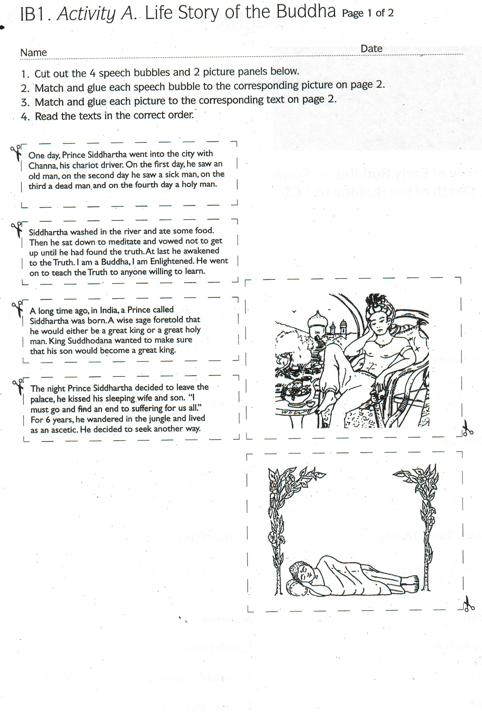

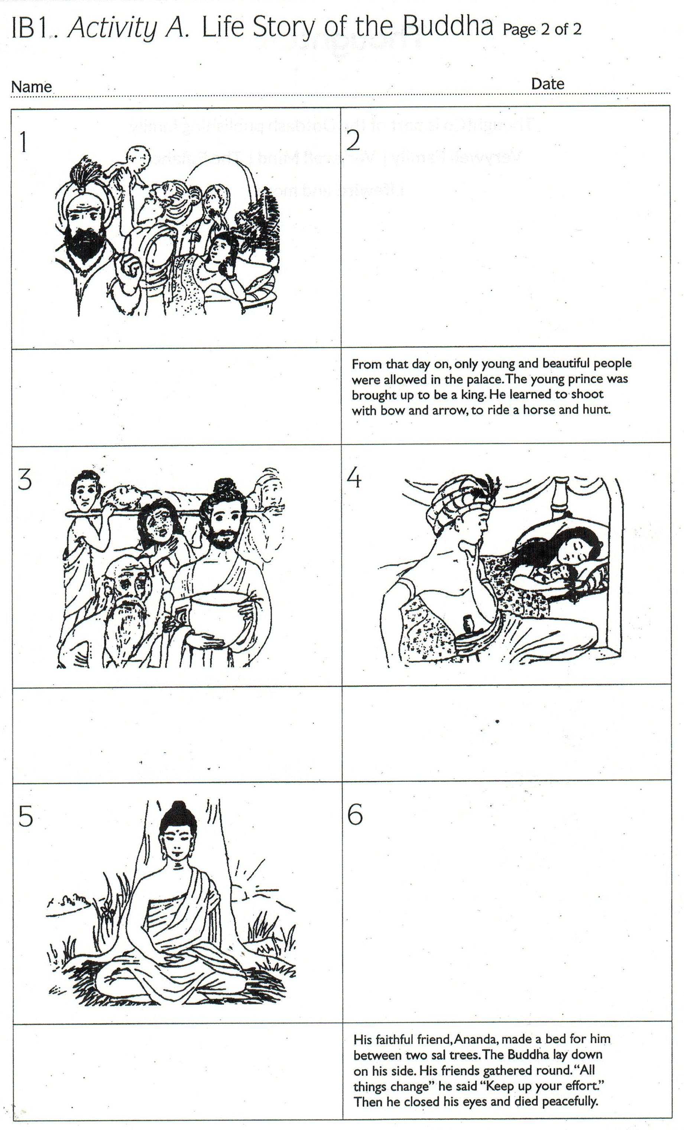

VIEN GIAC TEMPLE AUSTRALIA

Lesson Sequence | Time | Lesson Aim: To teach about the life of Buddha and to recognise his birth.  They will fill in the missing information to increase their focus skills.  Resources: Students will need birth certificate, led pencils.
Chanting | 10 min | - Recite name of Master Buddha-express respect and gratefulness to  the Shakyamuni Buddha.  Nam Mô Shakyamuni Buddha (3 times),  2. Breathing meditation –connect mind and body to the present.  Next breath in, breath out breath meditation (3 times),  3. Chanting Amitabha- peaceful Buddha- lead to complete mindfulness,  followed by Chanting Amitabha student repeat after teacher (3 times)
Story | 5min | A Prince Is Born  About 2,600 years ago, there lived a great king named Suddhodana Gotama. He had a pretty wife called Maya. They lived at the bottom of the Himalayan Mountains in northern India.  One night, Queen Maya had a wonderful dream. She saw a huge white elephant come into her room. It was holding a lotus flower. The elephant blew its trunk as it was walking around her bed three times.  In the morning, the king asked his wise men about the queen’s dream. They said, “Oh King! A great son will be born to Queen Maya.” The king and queen were very happy with this news.  On the day of the full moon in May, Queen Maya gave birth to Prince Siddhartha in a pretty royal park. All the trees were in flower. The bees were humming around the fresh flowers. The birds were singing sweetly. Everyone was happy because a prince had been born.
Questioning  and Discussion | 5min | - What was the Prince Named?  (Siddhartha)  - Where was he born?  (A royal park)  - What country was he born in?  (India)  4. What were his parent’s names?  (Maya and Suddhodana Gotama)  - What were their occupations?  (King and Queen)
Student Activity | 5min | Students will fill in the missing information on Prince Siddhartha’s birth certificate
Term One: Stage 2 Lesson 2: A Prince Is Born

VIEN GIAC TEMPLE AUSTRALIA

Activity 2: A Prince Is Born

Birth Certificate

1. Child | Name:
 | Place of birth:
 | Country of birth:
2. Mother | Name:
 | Occupation:
3. Father | Name:
 | Occupation:

Queen King Maya India

Suddhodana Gotama Siddhartha A Royal Park

VIEN GIAC TEMPLE AUSTRALIA

Term One: Stage 2 Lesson 3: The Young Prince
Lesson Sequence | Time | Lesson Aim: To teach about the life of Buddha and to recount his early life and to understand what the Prince gave up in order to begin searching for the truth.
Chanting | 10 min | - Recite name of Master Buddha-express respect and gratefulness to  the Shakyamuni Buddha.  Nam Mô Shakyamuni Buddha (3 times),  - Breathing meditation –connect mind and body to the present.  Next breath in, breath out breath meditation (3 times),  - Chanting Amitabha- peaceful Buddha- lead to complete mindfulness,  followed by Chanting Amitabha student repeat after teacher (3 times)
Story | 5min | The Young Prince  As time passed, Siddhartha grew up. He married the beautiful Princess Yashodhara and they had a son called Rahula. The King was delighted, his plan was working.  “How happy Siddhartha is here in the palace with his beautiful princess and his baby son” he thought. “He has his own parks and swimming pools and everything he could wish for. He will never want to leave. One day he will be a great king”.  But prince Siddhartha wasn’t happy at all. “I don’t want to be shut up in the palace all day. I need to go out and see the world” he said.
Questioning  and Discussion | 5min | - Who did Prince Siddhartha marry?  (Princess Yashodhara)  - What was their son named?  (Rahula)  - Why wasn’t the Prince happy?  (He wanted to go out and see the world)  - What did the Prince give up in order to go and search for the truth?  (all of the luxuries he had in the palace e.g. servants, jewelry, a big home, fancy clothes, lots of food etc.).
Student Activity  Teacher Led | 5min | Teacher will ask the students to think about luxuries we don’t need. Brainstorm their answers and write on the whiteboard.

VIEN GIAC TEMPLE AUSTRALIA

Term One: Stage 2 Lesson 4: The Four Sights
Lesson Sequence | Time | Lesson Aim: To teach students about the four sights the Prince saw and the effect they had on him.  Resources: Students will colour pencils and worksheet 4 about The Four Sights.
Chanting | 10 min | 1. Recite name of Master Buddha-express respect and gratefulness to  the Shakyamuni Buddha.  Nam Mô Shakyamuni Buddha (3 times),  2. Breathing meditation –connect mind and body to the present.  Next breath in, breath out breath meditation (3 times),  3. Chanting Amitabha- peaceful Buddha- lead to complete mindfulness,  followed by Chanting Amitabha student repeat after teacher (3 times)
Story | 5min | The Four Sights  One day, Prince Siddhartha went out into the city with Channa, his chariot driver. Soon, they met an old man leaning on a stick and walking very slowly. His hair and teeth were falling out.  Siddhartha was puzzled. “What’s that?” he asked. ”Old age,” said Channa. “Everyone grows old.” This sight upset the prince.  On the second day, Prince Siddhartha went out and he saw a sick man. “What’s happened?’ he asked. “Sickness.” Said Channa. “Everyone gets ill some time in their life.” Siddhartha was shocked. He had never before seen anyone who was ill.  On the third day, he went out again and saw something even worse. He saw a funeral. “Death has come,” said Channa. “Everyone has to die”. That’s terrible,” said Siddhartha. “Why is there so much suffering? What can I do?  On the fourth day, they saw a man dressed in dimple robes and carrying a bowl. “There’s a holy man,” said Channa. “That’s all he owns.” And yet he looks so peaceful and happy, how strange” said Siddhartha.
Questioning  and Discussion | 5min | - What were the four sights the prince saw?  - Why was the Prince shocked?
Student Activity | 5min | Students will draw and label The Four Sights.

VIEN GIAC TEMPLE AUSTRALIA

Activity 4: The Four Sights

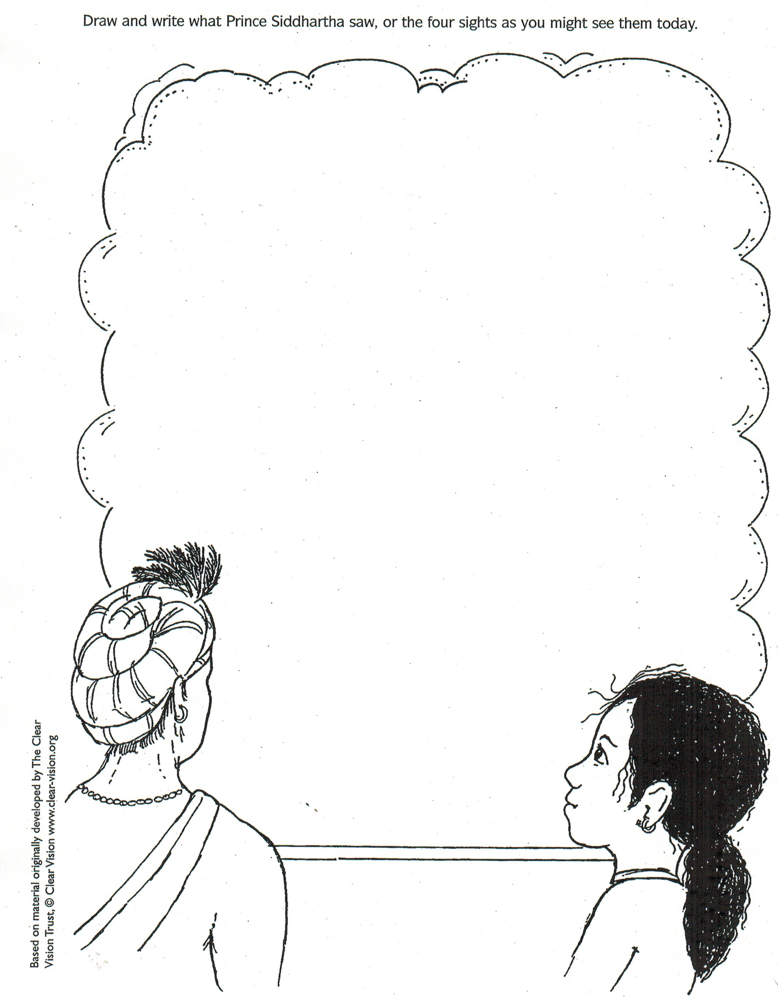

VIEN GIAC TEMPLE AUSTRALIA

Term One: Stage 2 Lesson 5: The Leaving Home

Lesson Sequence | Time | Lesson Aim: To teach students about the sacrifice the Prince made in order to find an end to suffering.  Resources: Students will colour pencils and worksheet 5 about the Prince leaving home.
Chanting | 10 min | 1. Recite name of Master Buddha-express respect and gratefulness to  the Shakyamuni Buddha.  Nam Mô Shakyamuni Buddha (3 times),  2. Breathing meditation –connect mind and body to the present.  Next breath in, breath out breath meditation (3 times),  3. Chanting Amitabha- peaceful Buddha- lead to complete mindfulness,  followed by Chanting Amitabha student repeat after teacher (3 times)
Story | 5min | Leaving Home  That very night, Siddhartha decided to leave the palace. He kissed his sleeping wife and child; ”Goodbye,” he whispered, “I must go and find an end to suffering for us all.  Silently, Siddhartha and Channa crept out of the palace gates and rode off into the night. At last they came to a river at the edge of the forest.  Siddhartha cut off his long hair and put on simple robes. He gave his rich clothes, jewels and his horse to Channa. “Please return to the palace with these. I am no longer your master the Prince, I am Siddhartha the wanderer. I now go forth to find the Truth.”  Channa watched sadly as Siddhartha crossed the river and went off alone into the dark forest.
Questioning  and Discussion | 5min | - What made the Prince want to leave the palace?  (He needed to go and find an end to suffering)  - Why did he cut off his hair and change his clothes?  (He gave up his royal identity as the Prince)
Student Activity | 5min | Students will list 3 things the Prince gave to Channa and colour in the picture of the Prince saying goodbye to his wife.

VIEN GIAC TEMPLE AUSTRALIA

Activity 5: The Leaving Home

List the 3 things the Prince gave to Channa?

1.

2.

3.

Colour in the picture of the prince saying goodbye to his wife.
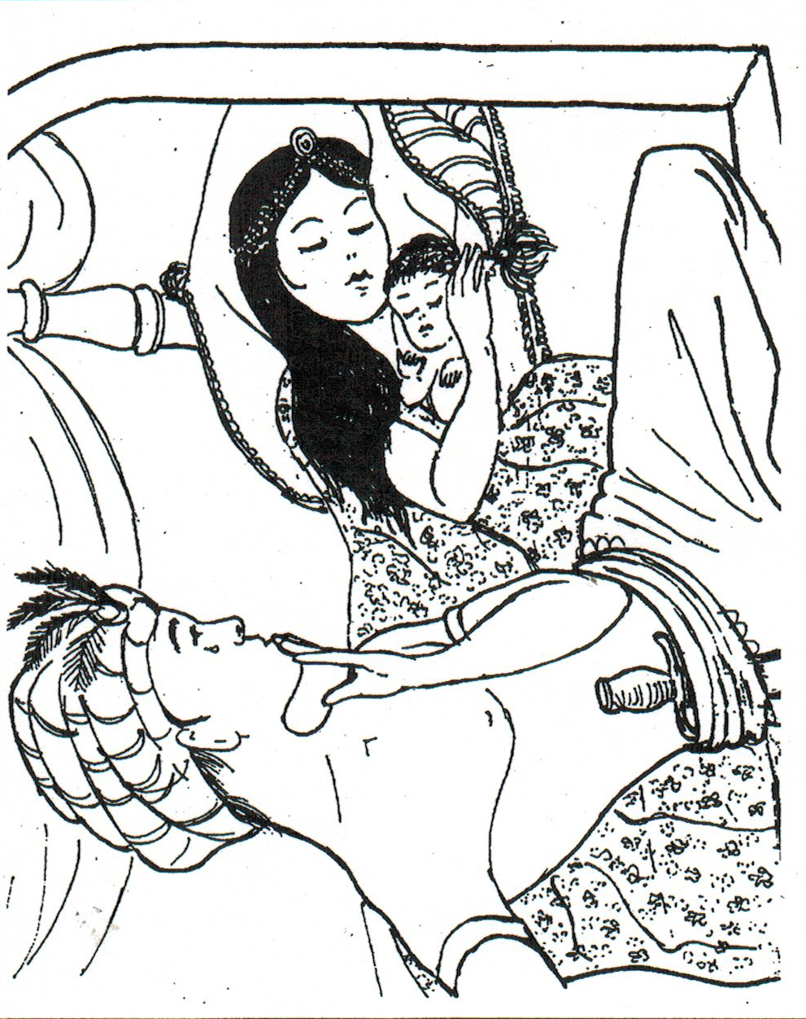

VIEN GIAC TEMPLE AUSTRALIA

Term One: Stage 2 Lesson 6: The Wandering Holy Man
Lesson Sequence | Time | Lesson Aim: To teach students about the four sights the Prince saw and the effect they had on him.  Resources: Students will colour pencils and worksheet 6 about The Wandering Holy Man.
Chanting | 10 min | 1. Recite name of Master Buddha-express respect and gratefulness to  the Shakyamuni Buddha.  Nam Mô Shakyamuni Buddha (3 times),  2. Breathing meditation –connect mind and body to the present.  Next breath in, breath out breath meditation (3 times),  3. Chanting Amitabha- peaceful Buddha- lead to complete mindfulness,  followed by Chanting Amitabha student repeat after teacher (3 times)
Story | 5min | The Wandering Holy Man  For six years, Siddhartha wandered in the jungle. He went to famous holy teachers. He learned all they had to teach him, but was still not satisfied. “I have still not learned the Truth”, he thought.  Then he lived with five friends. They were ascetics.  (An ascetic person has a way of life that is simple and strict).  They thought that by living a hard and uncomfortable life they would find the Truth. Siddhartha became and ascetic too.  He ate less and less food until he was living on only one grain of rice a day. He almost starved to death. “This isn’t helping,” he said, ”I am still no nearer to the Truth. A very rich life in the palace was not the way. A very hard and uncomfortable life is not the way. I will try a middle way.”  Siddhartha ate some milk-rice that a woman gave him. His friends did not agree. When the five ascetics saw this they didn’t like it. “He’s given up,” they said, and they left him.
Questioning  and Discussion | 5min | - What is an ascetic person?  (An ascetic person has a way of life that is simple and strict).  - Why didn’t being an ascetic person work for Siddhartha?  He almost starved to death and still didn’t find the truth?
Student Activity | 5min | Students will complete a close passage about the Prince’s experience while he was wandering.

VIEN GIAC TEMPLE AUSTRALIA

Activity 6: The Wandering Holy Man

He ate less and less __________until he was living on only one grain of rice a day. He almost ________________to death. “This isn’t helping,” he said, ”I am still no nearer to the_______________. A very rich life in the palace was not the way. A very hard and uncomfortable life is not the way. I will try a _______________way.”
VIEN GIAC TEMPLE AUSTRALIA

starved middle food Truth
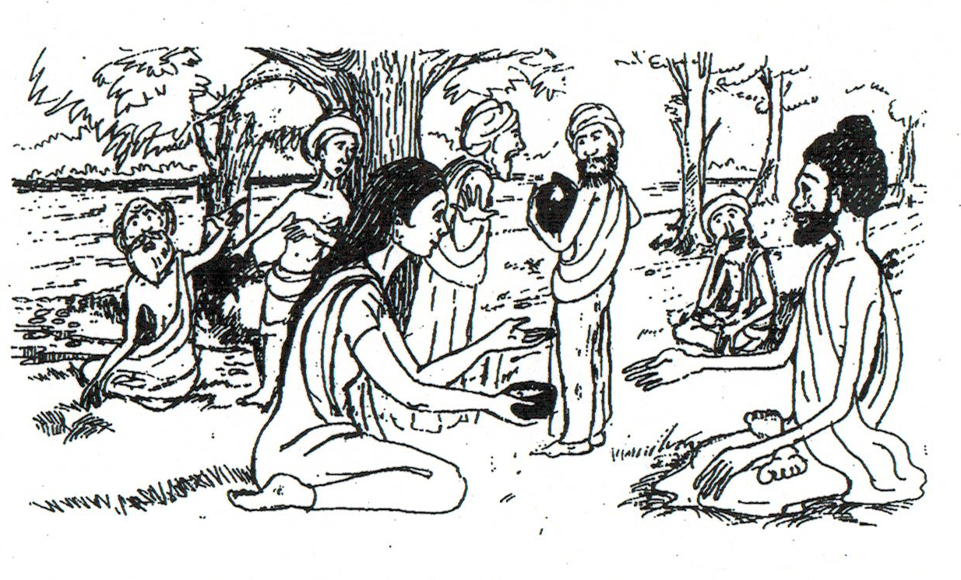

Lesson Sequence | Time | Lesson Aim: To teach students about the four sights the Prince saw and the effect they had on him.  Resources: Students will colour and cut out the picture of Buddha
Chanting | 10 min | 1. Recite name of Master Buddha-express respect and gratefulness to  the Shakyamuni Buddha.  Nam Mô Shakyamuni Buddha (3 times),  2. Breathing meditation –connect mind and body to the present.  Next breath in, breath out breath meditation (3 times),  3. Chanting Amitabha- peaceful Buddha- lead to complete mindfulness,  followed by Chanting Amitabha student repeat after teacher (3 times)
Story | 5min | The Enlightenment  Siddhartha washed in the river and ate some food. Then he sat down to meditate in the shade of a Bodhi tree. He felt much stronger. “I will sit here until I have won,” he said. “I will never give up, even if I have stay here until my blood dries up.”  He meditated all night. In the morning, just as the sun rose, he knew he had won. “I have done it. I am free from suffering. I understand.  At last I am awake to the Truth. Now I am a Buddha. I am Enlightened.
Questioning  and Discussion | 5min | - What was the name of the tree he sat under?  (Bodhi tree)  - What did he do when he sat under the tree?  (He mediated)
Student Activity | 5min | Students will colour and cut out the Buddha.

Term One: Stage 2 Lesson 7: The Enlightenment

VIEN GIAC TEMPLE AUSTRALIA

Activity 7: The Enlightenment
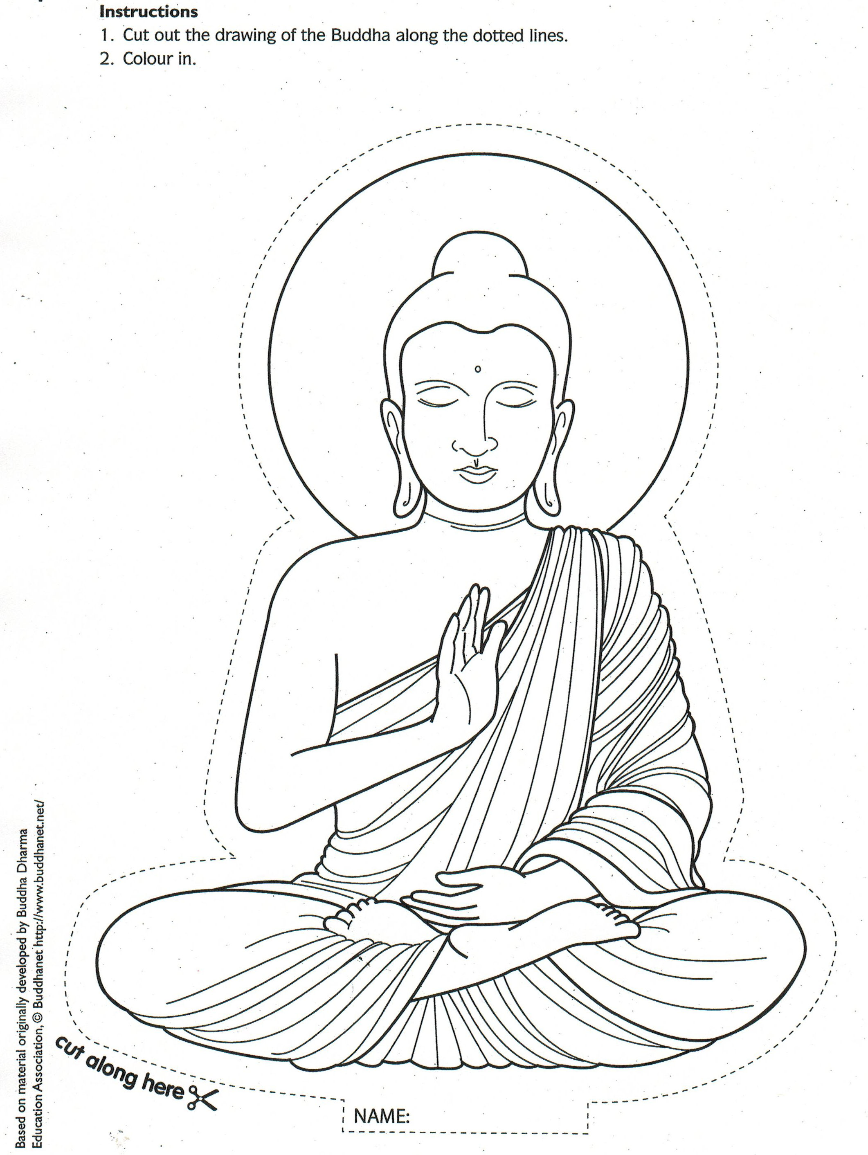
VIEN GIAC TEMPLE AUSTRALIA

Lesson Sequence | Time | Lesson Aim: To teach students about the four sights the Prince saw and the effect they had on him.  Resources: Students will colour and cut out the picture of Buddha
Chanting | 10 min | 1. Recite name of Master Buddha-express respect and gratefulness to  the Shakyamuni Buddha.  Nam Mô Shakyamuni Buddha (3 times),  2. Breathing meditation –connect mind and body to the present.  Next breath in, breath out breath meditation (3 times),  3. Chanting Amitabha- peaceful Buddha- lead to complete mindfulness,  followed by Chanting Amitabha student repeat after teacher (3 times)
Story | 5min | The Parinirvana  For forty-five years, the Buddha travelled around India, teaching the Dharma to anyone who would listen. Kings and Queens, rich and poor, men, women and children all became his followers and joined the Shangha.  At last, at the age of eighty, he knew that the time had come for him to die and so he called his followers to him.  “Do you have any last questions about my teachings? He asked. He wanted to be sure that they understood everything properly.  His faithful friend, Ananda, made a bed for him between two Sal Trees. The Buddha lay down on his side. His friends gathered around.  “All things change,” he said, “Keep up your effort. “Then he closed his eyes and died peacefully.
Questioning  and Discussion | 5min | Why did Buddha as his followers if they had any last questions?  (He wanted to be sure that his followers understood his teachings.)
Student Activity | 5min | Students will answer comprehension questions about the Parinirvana.
Term One: Stage 2 Lesson 8: The Parinirvana

VIEN GIAC TEMPLE AUSTRALIA

Activity 8: The Parinirvana

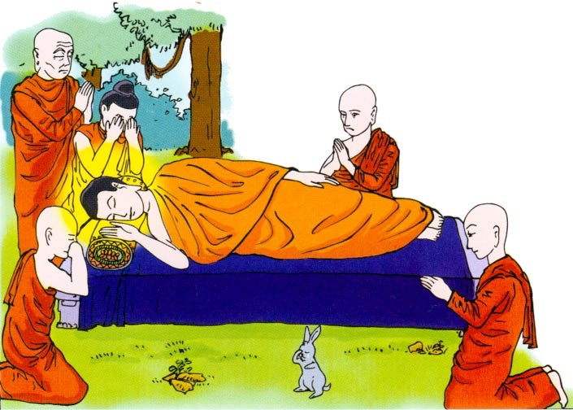

- How long did Buddha travel around India teaching Dharma?

- How old was Buddha when he knew that the time had come for him to die?

- Why did he call his followers to him?

- Where did his friend Ananda make his bed?

VIEN GIAC TEMPLE AUSTRALIA

Lesson Sequence | Time | Lesson Aim: To teach students about the four sights the Prince saw and the effect they had on him.  Resources: Students will colour and cut out the picture of Buddha
Chanting | 10 min | 1. Recite name of Master Buddha-express respect and gratefulness to  the Shakyamuni Buddha.  Nam Mô Shakyamuni Buddha (3 times),  2. Breathing meditation –connect mind and body to the present.  Next breath in, breath out breath meditation (3 times),  3. Chanting Amitabha- peaceful Buddha- lead to complete mindfulness,  followed by Chanting Amitabha student repeat after teacher (3 times)
Questioning  and Discussion | 5min | Life of the Buddha – Review  Ask the children what they know about Buddha?  Reflect on the stories that have been told throughout the term.  Ask the children to retell the story of Buddha’s life in the correct order.
Student and teacher Joint Activity | 5min | Record the students’ answers on the whiteboard.  Order the events in the correct order.
Student Activity | 5min | Students will order Buddha’s life events in the correct order.
Term One: Stage 2 Lesson 9: Life of Buddha- Review

VIEN GIAC TEMPLE AUSTRALIA

Activity 9: Life of Buddha- Review TEACHER ASWER SHEET

2. The wise men told the king that a prince will be born. | 4. He looked after a badly hurt swan, which was shot by his cousin. He knew animals wanted to live.
7. At age 29 he left the place and his family to find a way to make everyone happy. He searched for the next 6 years. | 3. Queen Maya gave birth to Prince Siddhartha on a full-moon day of May in a royal park.
5. The Prince had many teachers in the palace, he was a very good student. His father wished he would become king. | 8. He sat under a Bodhi Tree and meditated. At the age of 35 he found a way to make people happy. From then on he was called Buddha.
19. Buddha spread his teachings for the next 45 years. | 6. The Prince saw 4 people in a village. He saw a sick man, an old man, a dead man and a holy man.
1. Queen Maya had a wonderful dream. | 10. Buddha died at age 80.

VIEN GIAC TEMPLE AUSTRALIA

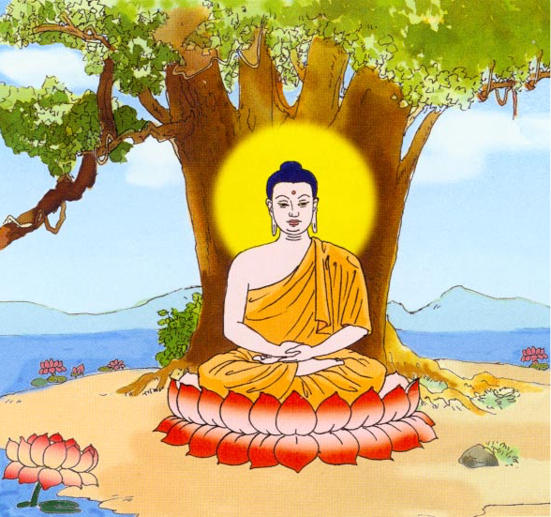
Activity 9: Life of Buddha- Review

Number each life event in the correct order.
The first one has been done
for you.

The wise men told the king that a prince will be born. | He looked after a badly hurt swan, which was shot by his cousin. He knew animals wanted to live.
At age 29 he left the place and his family to find a way to make everyone happy. He searched for the next 6 years. | Queen Maya gave birth to Prince Siddhartha on a full-moon day of May in a royal park.
The Prince had many teachers in the palace, he was a very good student. His father wished he would become king. | He sat under a Bodhi Tree and meditated. At the age of 35 he found a way to make people happy. From then on he was called Buddha.
Buddha spread his teachings for the next 45 years. | The Prince saw 4 people in a village. He saw a sick man, an old man, a dead man and a holy man.
1.  Queen Maya had a wonderful dream. | Buddha died at age 80.

VIEN GIAC TEMPLE AUSTRALIA

Term One: Stage 2 Lesson 10: How is Buddha important today?
Lesson Sequence | Time | Lesson Aim: To teach students about the four sights the Prince saw and the effect they had on him.  Resources: Students will colour and cut out the picture of Buddha
Chanting | 10 min | 1. Recite name of Master Buddha-express respect and gratefulness to  the Shakyamuni Buddha.  Nam Mô Shakyamuni Buddha (3 times),  2. Breathing meditation –connect mind and body to the present.  Next breath in, breath out breath meditation (3 times),  3. Chanting Amitabha- peaceful Buddha- lead to complete mindfulness,  followed by Chanting Amitabha student repeat after teacher (3 times)
Background information for discussion. | 5min | How is Buddha important today?  Prince Siddhartha found the path to Enlightenment. By doing so he was led from the pain of suffering and towards the path of Enlightenment and became known as the Buddha.  After Buddha passed away, the community he founded slowly evolved into a religion and the teachings of Buddha became the basis of Buddhism.  Buddha is both an individual and a symbol for a new way of being. The symbol of Buddha reminds us that his teachings guide us to live a happy and wise life
Questioning  and Discussion | 5min | What is Buddha important to us today?  (Buddha reminds us of his teachings and guides us to live a happy and healthy life)
Student Activity | 5min | Students will colour in the picture of living beings living in harmony

VIEN GIAC TEMPLE- AUSTRALIA

Activity 10: Harmony

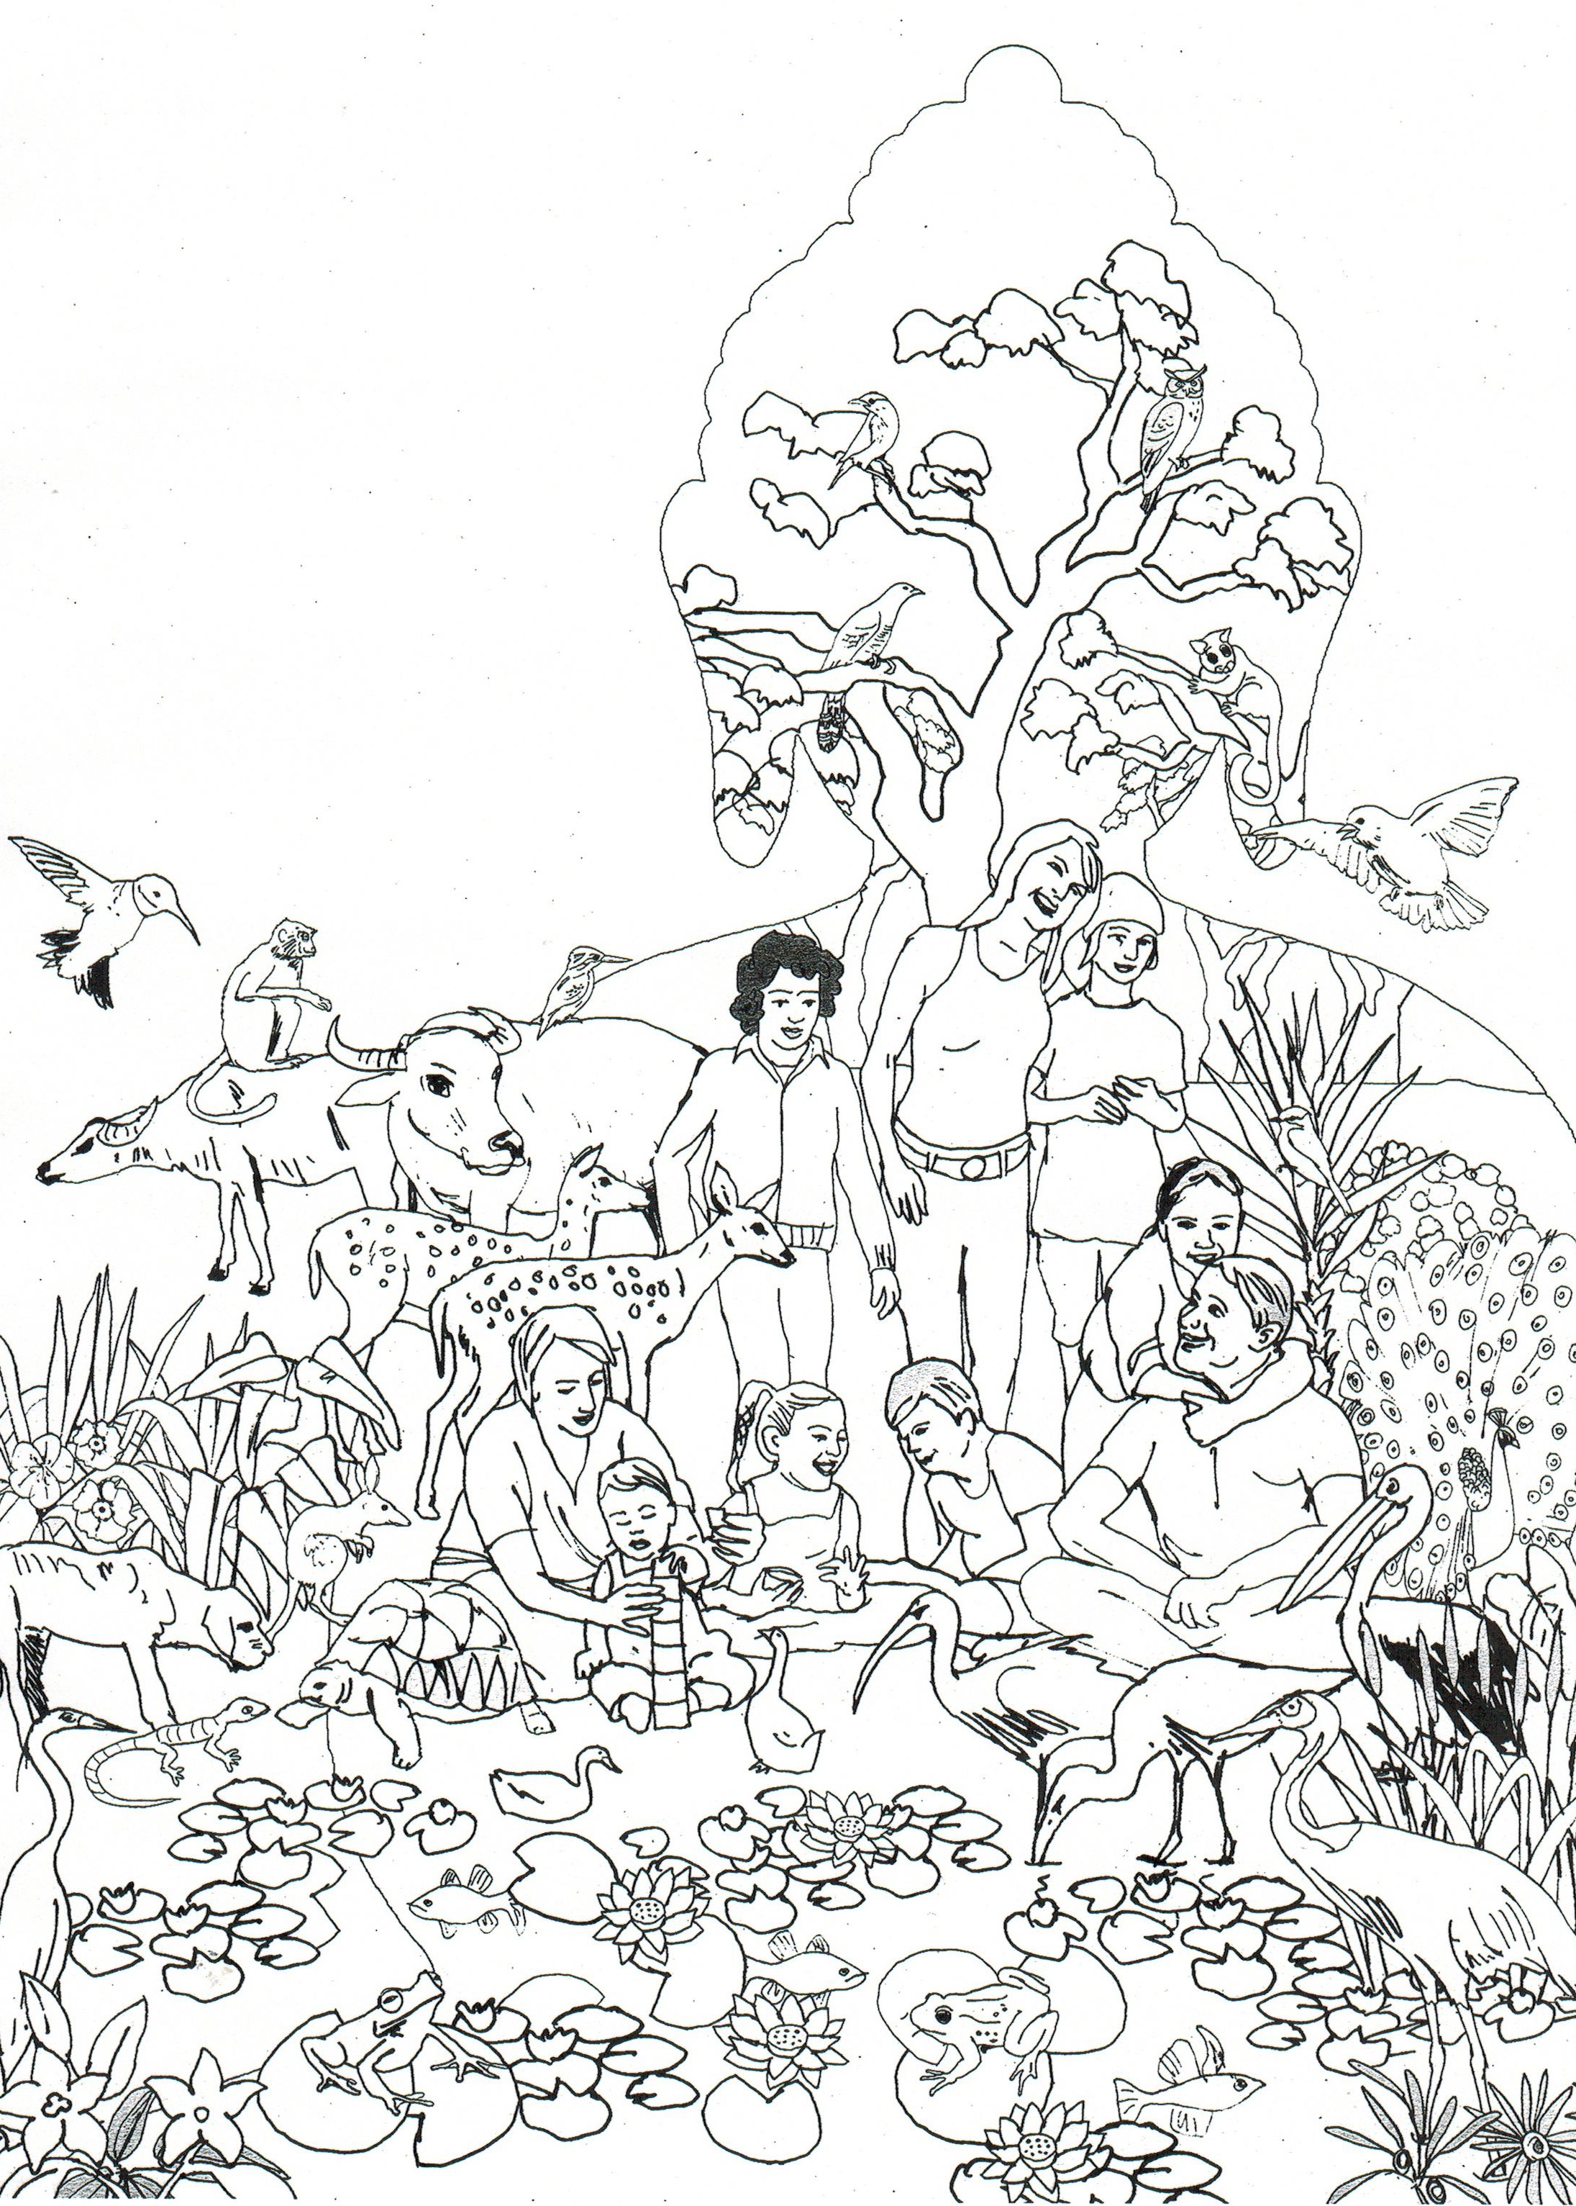
VIEN GIAC TEMPLE- AUSTRALIA

