Wk | Term 2
1 | What do Buddhists Believe?  Introduction
2 | The Appearance of the Buddha (DB/IB3
3
4 | The Four Noble Truths (B2/U2)
5
6 | The Sangha (nuns and monks) (B2/U2)
7
8 | Where do Buddhists live today? (DB/IB5)
9
10 | What do Buddhists Believe?

Stage Two: Term 2 Weekly Overview

VIEN GIAC TEMPLE- AUSTRALIA

Term Two: Stage 2 Lesson 1: What Do Buddhist Believe
Unit Introduction
Lesson Sequence | Time | Lesson Aim: To outline some key Buddhist beliefs.  Resources: Students will need the Buddhist Beliefs comprehension activity.
Chanting | 10 min | - Recite name of Master Buddha-express respect and gratefulness to the Shakyamuni Buddha.  Nam Mô Shakyamuni Buddha (3 times),  - Breathing meditation –connect mind and body to the present.  Next breath in, breath out breath meditation (3 times),  - Chanting Amitabha- peaceful Buddha- lead to complete mindfulness,  followed by Chanting Amitabha student repeat after teacher (3 times)
Questioning  and Discussion | 5min | - Ask children what they already know about Buddhist Beliefs.  - Write key words on the board  - Explain lesson information.
Lesson Information | 5min | The Buddha's teachings are known as Dharma. They include Buddhism's Four Noble Truths and the Eightfold Path (or Middle Way).  The Buddha  There are many key features of Buddha. Some of these are  - His noble face (Buddha looks serene)  - His Earlobes (long earlobes)  - The Mudras (Buddha’s hand gestures represent aspects of the Dharma)  - The Halo around his head (The halo represents Buddha’s wisdom and purity)  The Dharma: Buddhism's Noble Truths are:  - Life always involves suffering (Dukkha).  - Suffering happens because people are greedy and not satisfied with what they have.  - Greed and selfishness can cause suffering.  - The way to end suffering is to follow the Eightfold Path.  The Sangha  The Sangha is a group monks and nuns. They give up materialistic possessions to live a simple life; they follow Shakyamuni Buddha’s Dharma. They spread the teachings of Shakyamuni Buddha.  The Three Jewels of Buddhism are a belief in the Buddha, the Dharma and Sangha
Student Activity | 5min | Students will respond to a short comprehension activity about Buddhism

VIEN GIAC TEMPLE- AUSTRALIA

Term Two: Stage 2 Activity 1: What Do Buddhist Believe
Unit Introduction

Buddhist Beliefs

What are some features of Buddha’s appearance?

1. __________________________________

2. __________________________________

What can you remember about the Noble Truths?

1. __________________________________

2. __________________________________

3. __________________________________

4. __________________________________

What two things do you remember about the Sangha?

1. __________________________________

2. __________________________________

VIEN GIAC TEMPLE- AUSTRALIA

Term Two: Stage 2 Lesson 2: The Appearance of Buddha

Lesson Sequence | Time | Lesson Aim: To outline some key features of Buddha’s appearance.  Resources: Students will need The Appearance of Buddha worksheet.
Chanting | 10 min | - Recite name of Master Buddha-express respect and gratefulness to the Shakyamuni Buddha.  Nam Mô Shakyamuni Buddha (3 times),  - Breathing meditation –connect mind and body to the present.  Next breath in, breath out breath meditation (3 times),  - Chanting Amitabha- peaceful Buddha- lead to complete mindfulness,  followed by Chanting Amitabha student repeat after teacher (3 times)
Questioning  and Discussion | 5min | - Ask children what they already know about Buddha’s appearance.  - Write key words on the board
Lesson Information | 5min | The Appearance of Buddha  - Outline 4 features of Buddha’s appearance that were introduced in the previous lesson.  There are many key features of Buddha. Some of these are  - His noble face (Buddha looks serene)  - His Earlobes (long earlobes)  - The Mudras (Buddha’s hand gestures represent aspects of the Dharma)  - The Halo around his head (The halo represents Buddha’s wisdom and purity)  This lesson will focus on the first two features -  1. His noble face and 2. His earlobes.  Buddha’s noble face expresses serenity. He looks calm and gentle. His face shows kindness and peacefulness.  Buddha’s long earlobes represent his ability to listen and spiritually hear the voices of all beings. Buddha’s long earlobes remind us to listen to each other with kindness and patience.
Student Activity | 5min | Students will label the four key features of Buddha’s appearance.

VIEN GIAC TEMPLE- AUSTRALIA

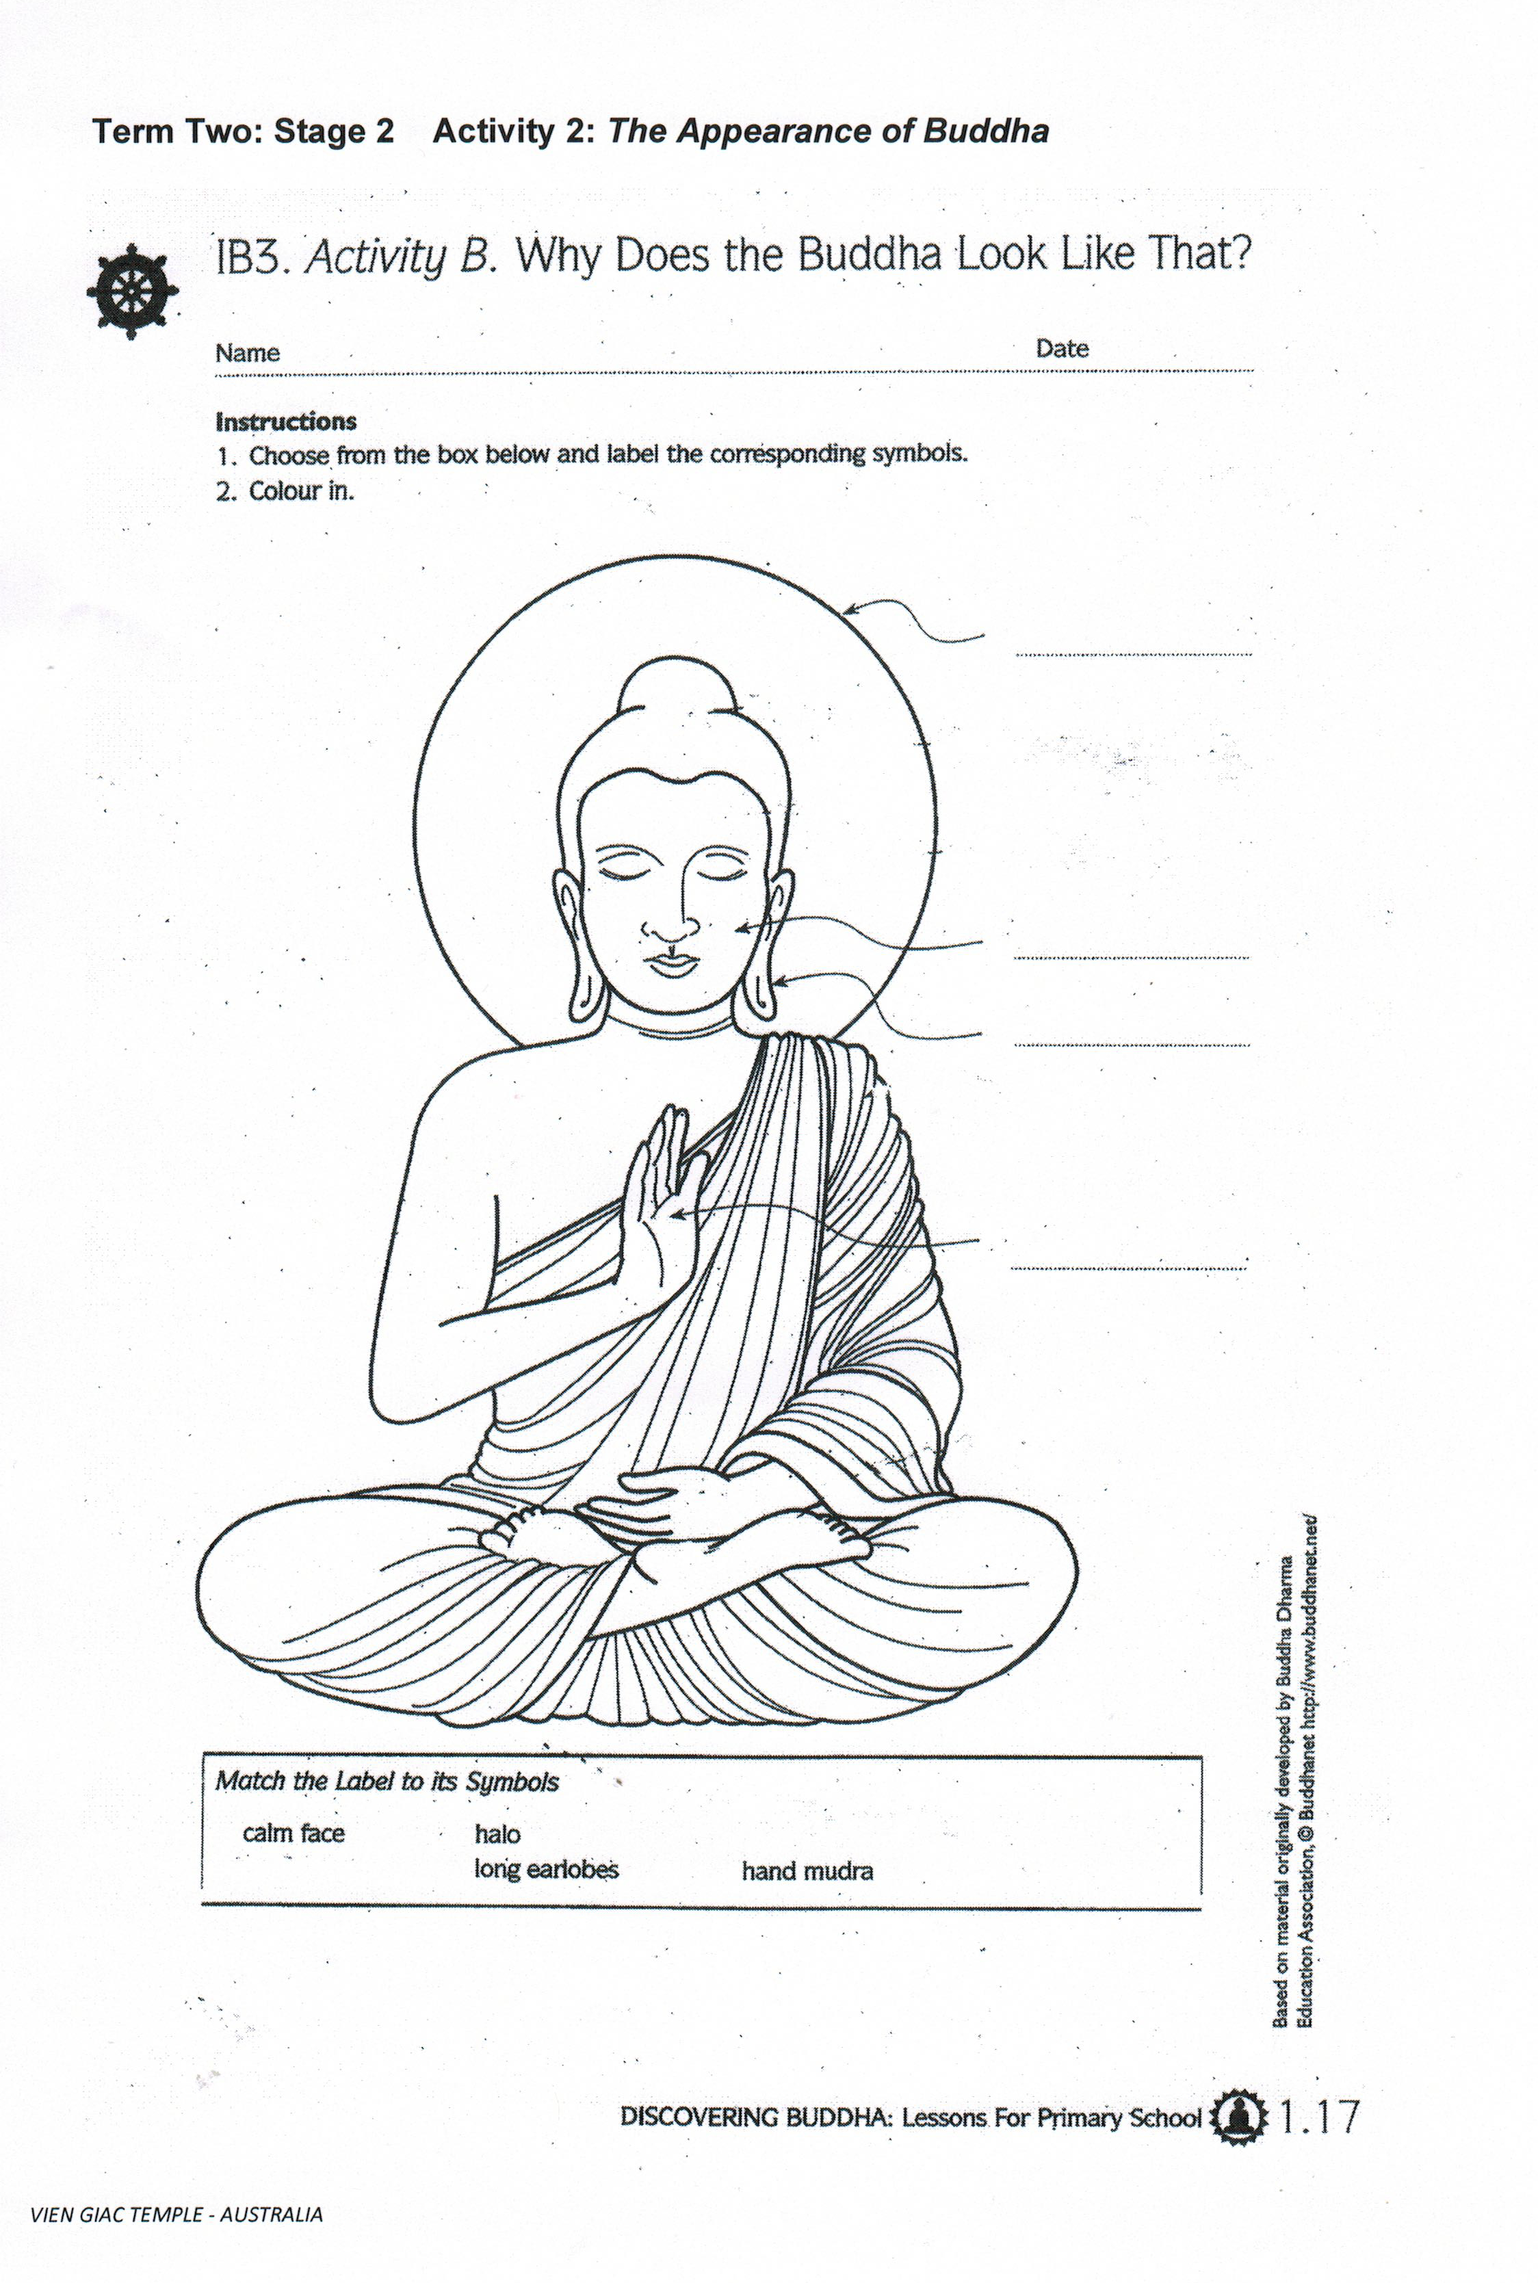

Term Two: Stage 2 Lesson 3: The Appearance of Buddha

Lesson Sequence | Time | Lesson Aim: To outline some key features of Buddha’s appearance.  Resources: Students will need the Buddha’s Appearance worksheet (hand mudras).
Chanting | 10 min | - Recite name of Master Buddha-express respect and gratefulness to the Shakyamuni Buddha.  Nam Mô Shakyamuni Buddha (3 times),  - Breathing meditation –connect mind and body to the present.  Next breath in, breath out breath meditation (3 times),  - Chanting Amitabha- peaceful Buddha- lead to complete mindfulness,  followed by Chanting Amitabha student repeat after teacher (3 times)
Questioning  and Discussion | 5min | - Ask children what they already know about Buddha’s appearance.  - Revise key features that were introduced in the previous lesson.  - Write key words on the board
Lesson Information | 5min | The Appearance of Buddha  - Outline 4 features of Buddha’s appearance that were introduced in the previous lesson.  There are many key features of Buddha. Some of these are  - His noble face (Buddha looks serene)  - His Earlobes (long earlobes)  - The Mudras (Buddha’s hand gestures represent aspects of the Dharma)  - The Halo around his head (The halo represents Buddha’s wisdom and purity)  This lesson will focus on the last two features -  3. The Halo around his head and 4. The Mudras  Buddha has an aura that shows that he is a noble person. The halo around Buddha’s head is a symbol of truth, wisdom and purity of the heart. This brightness represents light that shines on darkness.  A hand mudra is a sign using the hands to represent some gestures of Dharma. Some of the mudras symbolize Buddha’s teaching, respect, protection and meditation.
Student Activity | 5min | - Students will read the information about The Relaxed Concentration Mudra and the Teaching or Turning of the Wheel of Dharma Mudra.  - They will then practise using these gestures with a partner.

VIEN GIAC TEMPLE- AUSTRALIA

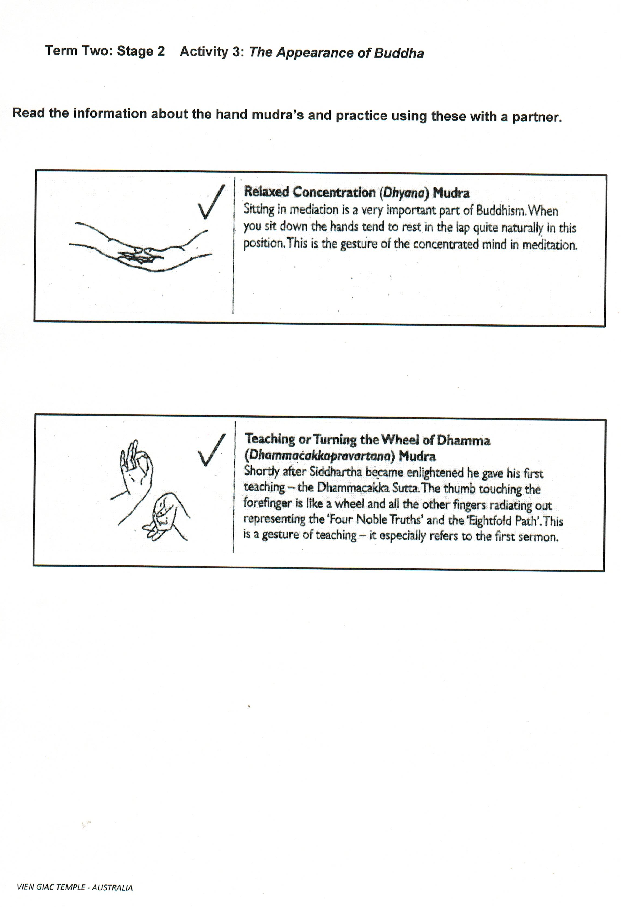

Term Two: Stage 2 Lesson 4: The Four Noble Truths
Lesson Sequence | Time | Lesson Aim: To Introduce The Four Noble Truths.  Resources: Teacher will need The Four Noble Truths Posters.
Chanting | 10 min | - Recite name of Master Buddha-express respect and gratefulness to the Shakyamuni Buddha.  Nam Mô Shakyamuni Buddha (3 times),  - Breathing meditation –connect mind and body to the present.  Next breath in, breath out breath meditation (3 times),  - Chanting Amitabha- peaceful Buddha- lead to complete mindfulness,  followed by Chanting Amitabha student repeat after teacher (3 times)
Questioning  and Discussion | 5min | - Ask children what they already know about The Four Noble Truths.  - Write key words on the board  - Explain lesson information.
Lesson Information | 5min | The Buddha's teachings are known as Dharma. They include Buddhism's Four Noble Truths and the Eightfold Path (or Middle Way).  The Dharma: Buddhism's Four Noble Truths are:  - Life always involves suffering (Dukkha).  - Suffering happens because people are greedy and not satisfied with what they have (Samudaya).  - The end of suffering (Nirvana).  - The way to end suffering is to follow the Eightfold Path (Magga).  This lesson will focus on the first two of The Four Noble Truths  The First Noble Truth- Life always involves suffering (Dukkha).  There are two types of pain. One sort of pain is the pain, which we can feel on our body. We call this physical pain. We feel this pain on our body when we get sick or if we have an accident and get hurt.  The other type of pain is when we feel sad. This sort of pain is caused by our thoughts. We feel this pain when we think about something that has made us feel unhappy.  The Second Noble Truth- Suffering happens because people are greedy and not satisfied with what they have (Samudaya).  Being selfishness and greedy can cause suffering.  -People are never happy or content with that they have. They always want more.
Student Activity  Teacher Directed | 5min | Teacher to show The Four Noble Truths Posters.  As a whole class brainstorm examples of the causes of suffering-  Some examples are:  - Physical pain- feeling sick, sore stomach, headache, falling off your bike.  - Pain from our thoughts- feeling sad because you lost a game, having no friends, being teased.  - Wanting more toys than you need, wanting more food than you need.

VIEN GIAC TEMPLE- AUSTRALIA

Term Two: Stage 2 Lesson 5: The Four Noble Truths
Lesson Sequence | Time | Lesson Aim: To Introduce The Four Noble Truths.  Resources: Teacher will need The Four Noble Truths Posters.
Chanting | 10 min | - Recite name of Master Buddha-express respect and gratefulness to the Shakyamuni Buddha.  - Nam Mô Shakyamuni Buddha (3 times),  Breathing meditation –connect mind and body to the present.  - Next breath in, breath out breath meditation (3 times),  Chanting Amitabha- peaceful Buddha- lead to complete mindfulness,  - followed by Chanting Amitabha student repeat after teacher (3 times)
Questioning  and Discussion | 5min | - Ask children what they already know about The Four Noble Truths.  - Revise the previous lesson  - Explain lesson information.
Lesson Information | 5min | The Buddha's teachings are known as Dharma. They include Buddhism's Four Noble Truths and the Eightfold Path (or Middle Way).  The Dharma: Buddhism's Four Noble Truths are:  - Life always involves suffering (Dukkha).  - Suffering happens because people are greedy and not satisfied with what they have (Samudaya).  - The end of suffering (Nirvana).  - The way to end suffering is to follow the Eightfold Path (Magga).  This lesson will focus on the last two of The Four Noble Truths  The Third Noble Truth-  The True of END of suffering can be achieved by removing greediness, hatred, jealousy and anger. If we take these negative emotions away, we can be free from suffering (Nirvodha).

VIEN GIAC TEMPLE- AUSTRALIA
Lesson Information  Continued |  | The Fourth Noble Truth-  The pathway to end suffering. Shakyamuni Buddha developed a way of life called the Eightfold Path, which meant his basic needs were catered for (food, clothing and shelter) but he did not look for any extra comforts. Buddhists still try to live according to the Eightfold Path  The Eight- Fold Path  - Right viewpoint (looking at life the right way and accepting the Buddha's teachings)  - Right values / thought (using the power of the mind in the right way and thinking about other people without being selfish)  - Right speech (making sure that your words are kind and helpful and be truthful)  - Right actions (treating yourself and other people with respect)  - Right livelihood (having a job that does not harm any living beings)  - Right effort (doing good things and avoiding bad things)  - Right mindfulness (training the mind to see things in the right way)  - Right meditation (learning to concentrate and calm the mind by using breathing meditation)
Students activity  Teacher directed | 5min | Teacher will ask students to name the four Noble Truths in the correct order. Use the posters as a guide.

VIEN GIAC TEMPLE- AUSTRALIA

Term Two: Stage 2 Lesson 6: The Sangha (Nuns and Monks)
Lesson Sequence | Time | Lesson Aim: To outline some key features of The Sangha
Chanting | 10 min | - Recite name of Master Buddha-express respect and gratefulness to the Shakyamuni Buddha.  Nam Mô Shakyamuni Buddha (3 times),  - Breathing meditation –connect mind and body to the present.  Next breath in, breath out breath meditation (3 times),  - Chanting Amitabha- peaceful Buddha- lead to complete mindfulness,  followed by Chanting Amitabha student repeat after teacher (3 times)
Lesson Information | 5min | The Sangha  Buddhists aim to give up the need for material possessions. They concentrate on their inner development and gain much understanding into the nature of things by leading a pure and simple life. The Sangha is a group of monks or nuns. They practice the Dharma. They spread Buddha’s teachings to help people become happier and wiser.  Clothing  In the beginning, monks and nuns had only three robes. When Buddhism spread to colder countries, like China and Japan, they needed to wear more layers of clothes to keep warm. Their robes are simple and made from cotton or linen.  Shaven head  Buddhist monks and nuns shave their heads. They are not concerned with outward beauty, but with developing their inner beauty. Monks and nuns are easy to recognise with their shaven heads. The time they would have spent on caring for their hair is spent on more important activities like meditating, or chanting.  Alms bowl  Offering food to monks and nuns is a part of Buddhist practice. Since monks and nuns do not choose their food, they learn to be grateful for whatever they are given. This practice helps them to be humble. It also gives the disciples an opportunity to practice giving. The disciples go to the monastery to make offerings of food.  Robes and alms bowls are very important for monks and nuns. The Buddha said, “Just as a bird takes its wings with it wherever it flies, so the monks and nuns take their robes and bowls with them wherever they go. They are content with robes to cover their body and an alms bowl to hold their food.”
Questioning  and Discussion | 5min | Ask students to explain 1 point they remember about The Sangha, their clothing, shaven head or Alms bowl. Teacher to write answers on the board.
Student Activity | 5min | Students will label the key features of the Sangha
VIEN GIAC TEMPLE- AUSTRALIA

Term Two: Stage 2 Activity 7: The Sangha (Nuns and Monks)

Label the key representations of the Sangha

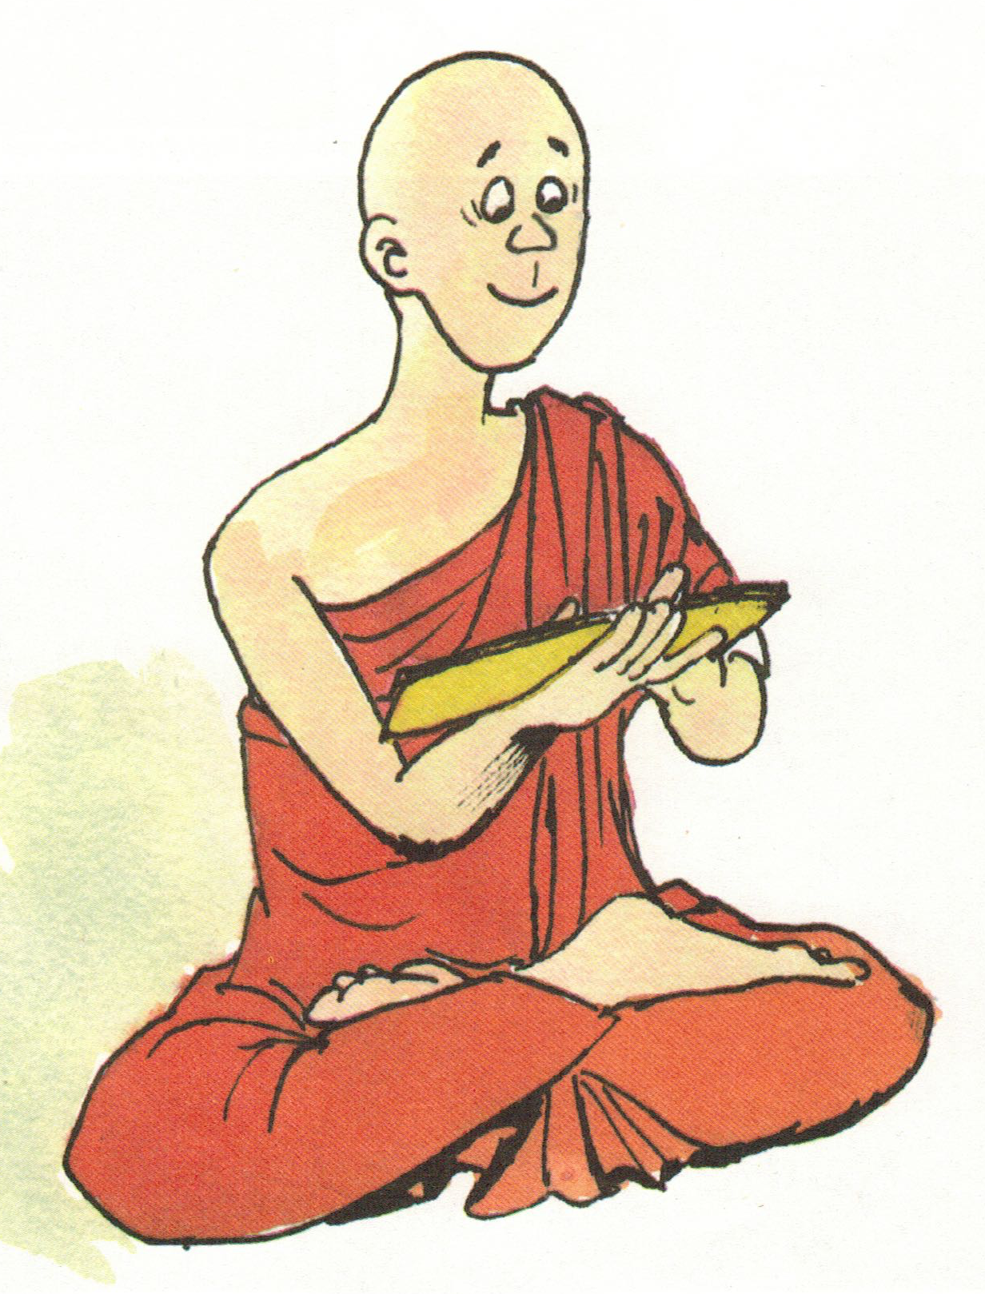

VIEN GIAC TEMPLE - AUSTRALIA

Lesson Sequence | Time | Lesson Aim: To outline some key roles and responsibilities of The Sangha
Chanting | 10 min | - Recite name of Master Buddha-express respect and gratefulness to the Shakyamuni Buddha.  Nam Mô Shakyamuni Buddha (3 times),  - Breathing meditation –connect mind and body to the present.  Next breath in, breath out breath meditation (3 times),  - Chanting Amitabha- peaceful Buddha- lead to complete mindfulness,  followed by Chanting Amitabha student repeat after teacher (3 times)
Questioning  and Discussion | 5min | Review concept taught about the Sangha in previous lesson.
Lesson Information | 5min | The Sangha  In the daily life of work and religious practice, the monks and nuns are mindful of what they do; they conduct themselves properly and with discipline. Each day begins early for monks and nuns. As early as 5am, they begin their day by reciting the Shurangama Mantra. They then attend morning ceremonies and recite parts of Buddha’s teachings. Later on, there may be a period of meditation and study.  Members of the Sangha have many responsibilities to fulfill, despite leading simple lives. They work very hard and are happy with the work they do. During the day, they go about teaching the Dharma. They take care of the temple and gardens. They give advice to the Buddhist members. They help with community services such as preparing for and conducting wedding ceremonies, funeral ceremonies and they preach Dharma to help the elderly and the sick overcome their suffering.  There are more chanting and meditation sessions in the evenings. Monks and nuns may give talks on the teachings of Buddha. In the evening they use their time for study or meditation.
Student Activity | 5min | Students will complete a close passage about the Sangha.
Term Two: Stage 2 Lesson 7: The Sangha (Nuns and Monks)

VIEN GIAC TEMPLE- AUSTRALIA

Term Two: Stage 2 Activity 7: The Sangha (Nuns and Monks)

Fill in the missing words.

The Sangha

Each day begins early for monks and nuns. As early as___________, they begin their day by reciting the Shurangama _______________. They then attend morning ceremonies and recite parts of Buddha’s teachings. Later on, there may be a period of ___________________and study.
Members of the Sangha have many responsibilities to fulfill, despite leading simple lives. They work very hard and are happy with the work they do. During the day, they go about teaching the____________________. They take care of the temple and gardens. They give advice to the Buddhist members. They help with community services such as preparing for and conducting wedding ceremonies, funeral ceremonies and they preach Dharma to help the elderly and the sick overcome their____________________.

Mantra suffering meditation 5am Dharma

VIEN GIAC TEMPLE- AUSTRALIA

Term Two: Stage 2 Lesson 8: Where do Buddhists live today?

Lesson Sequence | Time | Lesson Aim: To show where Buddhists live around the world
Chanting | 10 min | - Recite name of Master Buddha-express respect and gratefulness to the Shakyamuni Buddha.  Nam Mô Shakyamuni Buddha (3 times),  - Breathing meditation –connect mind and body to the present.  Next breath in, breath out breath meditation (3 times),  - Chanting Amitabha- peaceful Buddha- lead to complete mindfulness,  followed by Chanting Amitabha student repeat after teacher (3 times)
Questioning  and Discussion | 5min | Ask students about the origins of where their family came from.
Lesson Information | 5min | - Show students a map of the world.  - Ask students to identify where Australia is on the map.  - Ask students to identify where their families come from.  - Explain that there are different countries around the world where Buddhism is practiced.
Student Activity | 5min | Students will highlight on the world map where their family comes from.

VIEN GIAC TEMPLE- AUSTRALIA

Term Two: Stage 2 Activity 8: Where do Buddhists live today?

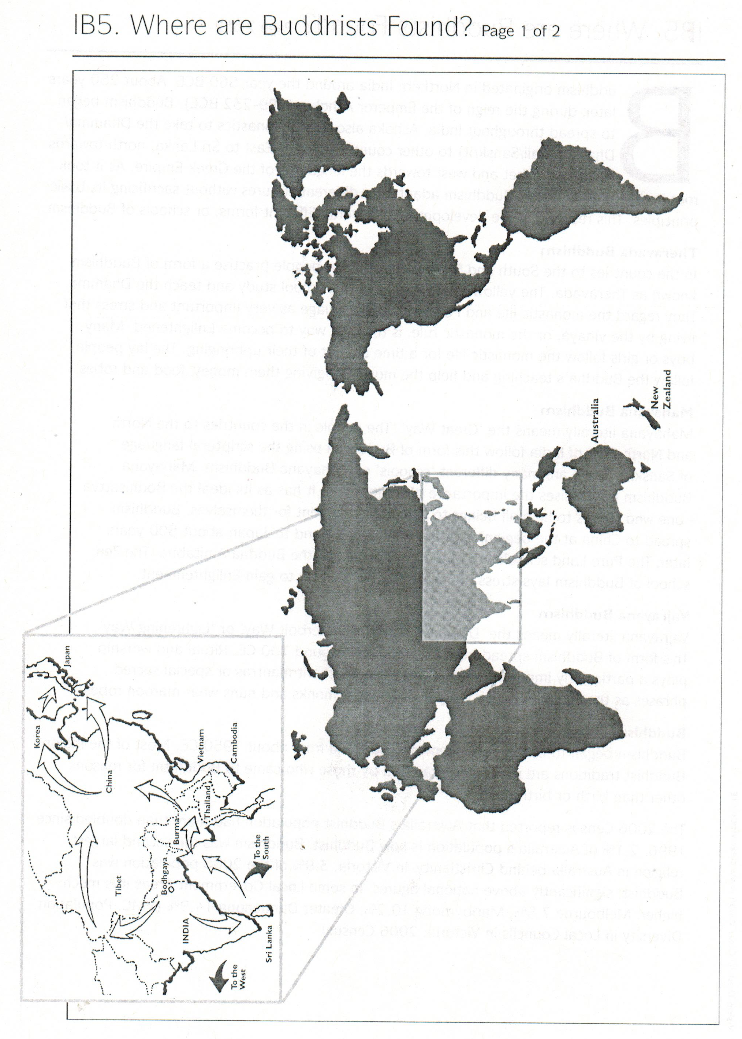

VIEN GIAC TEMPLE- AUSTRALIA

Term Two: Stage 2 Lesson 9: Where do Buddhists live today?

Lesson Sequence | Time | Lesson Aim: To show Buddhists live around the world and that people from different cultures practice Buddhism.
Chanting | 10 min | - Recite name of Master Buddha-express respect and gratefulness to the Shakyamuni Buddha.  Nam Mô Shakyamuni Buddha (3 times),  - Breathing meditation –connect mind and body to the present.  Next breath in, breath out breath meditation (3 times),  - Chanting Amitabha- peaceful Buddha- lead to complete mindfulness,  followed by Chanting Amitabha student repeat after teacher  (3 times)
Questioning  and Discussion | 5min | Ask students to tell the class what language they speak.
Lesson Information | 5min | - Show students a map of the world.  - Explain that in Buddhism there are different pronunciations according to the country of origin.  The Name of Buddha  Amitabha Buddha name in different languages:  - Sanskrit (Indian ancient language) is “Amitabha Buddhaya”  - Chinese language-“Amituofo”  - Thai language-“Amitabhh”  - Vietnamese language-“A Di Đà Phật”  - Japanese language-“Amid Butsu”.  In English speaking countries such as Australia the term Amitabha is  widely used.
Student Activity | 5min | Students will practise saying Amitabha in the different languages.

VIEN GIAC TEMPLE- AUSTRALIA

Term Two: Stage 2 Lesson 10: What do Buddhists Believe?
Lesson Sequence | Time | Lesson Aim: To outline some Buddhists beliefs.  Resources: A copy of the Buddhist Flag, Flag worksheet and coloured pencils.
Chanting | 10 min | - Recite name of Master Buddha-express respect and gratefulness to the Shakyamuni Buddha.  Nam Mô Shakyamuni Buddha (3 times),  - Breathing meditation –connect mind and body to the present.  Next breath in, breath out breath meditation (3 times),  - Chanting Amitabha- peaceful Buddha- lead to complete mindfulness,  followed by Chanting Amitabha student repeat after teacher  (3 times)
Lesson Information | 5min | Buddhist Flag  When visiting a monastery, there are several symbols that can be found. The images and statues of the Buddha are the most popular significant in a monastery. There are Bodhi Tree, Lotus Flowers, Dharma Wheels and Buddhist Flags. Each of these has a special meaning in Buddhism.  As the Buddha sat under the Bodhi Tree, six rays of light emitted from his body after his Enlightenment. The Buddhism flag represents the colours of the aura around Buddha  The vertical colours - Blue represents compassion, yellow the Middle Path, red signifies blessings of practice, white means purity and orange represents wisdom.  The horizontal colours on the Buddhist flag indicate that all the different races in the world can live happily under the shield of the Buddha’s wisdom.
Questioning  and Discussion | 5min | Show the class a picture of a Buddhist flag or an actual flag.
Student Activity | 5min | Students will colour in the Buddhist Flag using the correct colours.
VIEN GIAC TEMPLE- AUSTRALIA

Term Two: Stage 2 Activity 10: What do Buddhists Believe?

Colour the Buddhist flag in the correct colours

VIEN GIAC TEMPLE- AUSTRALIA

