**THE TRIPPLE GEM**

**THE SANGHA**

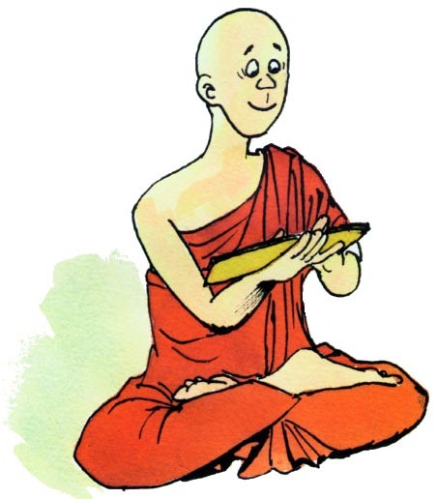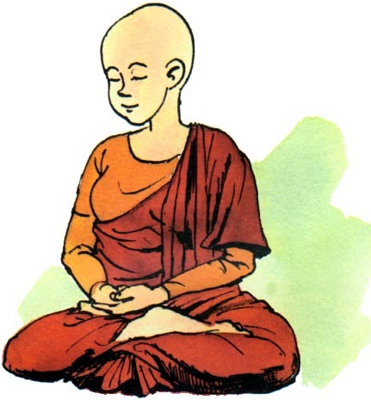

**THE DHARMA**

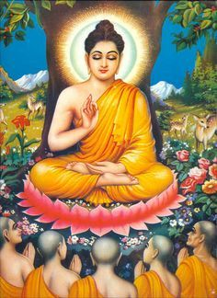

**THE BUDDHA**

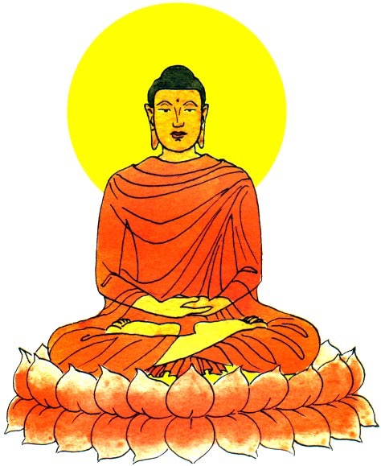

Dharma is the teachings of Shakyamuni Buddha.

**Enlightenment** is the most important goal for all Buddhists.

When we follow the Dharma, it brings much happiness and peace.

Live wisely and happily.

Face and solve daily problems.

The **Sangha** is a group of **monks** or **nuns**. They practice the Dharma.

Men become monks and women become nuns.

They wear brown, yellow and grey robes.

Monk and Nun have their head shaven

They live simple lives and focus their time teaching Dharma to those in needs

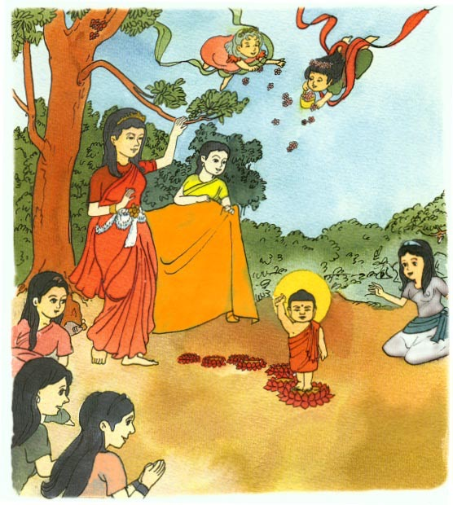

About 2,600 years ago, there lived a great king named **Suddhodana** **Gotama.**

He had a pretty wife called **Maya**. They lived at the bottom of the Himalayan Mountains in northern India.

On a full-moon day of May, **Queen Maya** gave birth to Prince **Siddhartha** in a pretty royal park.

**THE BUDDHA**



**Shakyamuni Buddha**

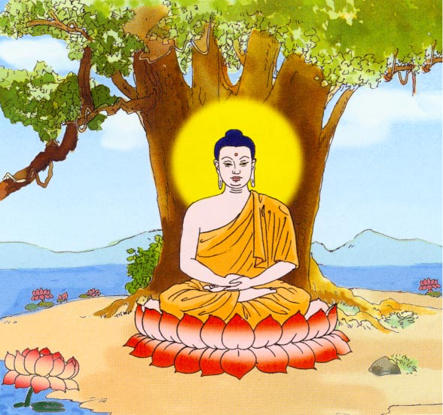

Shakyamuni Buddha is the first gem for Buddhists.

* He is the founder of Buddhism
* He was a wise teacher.
* He is the most honoured person in Buddhism.
* He teaches people to live wisely and happily.

**Shakyamuni**

**SAKYA-** The Surname of Buddha’s Tribe

**MUNI-** He who has understood the nature of the silence that lies beyond words.

**What did Shakyamuni Buddha Teach Us?**

He taught us how to think and act in ways that will free us from sadness.

Everything that happens to us is because of what we

**THINK**

**SAY**

**DO**

**Buddha**

**BUDH-** Awake

**DHA-** Someone who was awake

**THE DHARMA**



Make friends with good people. They will help us to become better people.

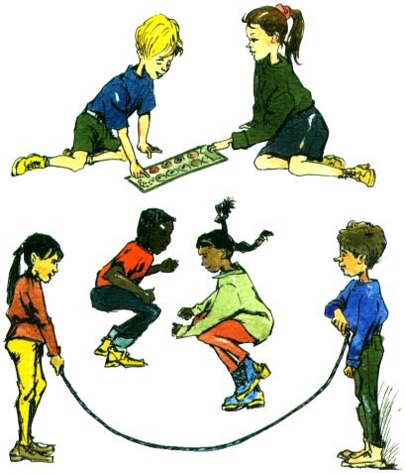

**The main teachings of Shakyamuni Buddha are:**

***LOVE AND COMPASSION for ALL LIVING BEINGS***

Be kind and respect all living creatures. We should not harm them; not even just for fun.

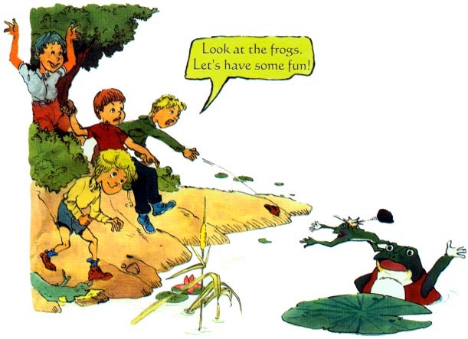

***THE FOUR GRATITUTE TEACHINGS OF SHAKYAMUNI BUDDHA***

**1**-Be grateful to parents

**2**-Be grateful to teachers

**3**- Be grateful to your country and

all sentients beings

**4**- Be grateful for the Three Treasures

Always respect and be grateful to our parents and teachers. They help us and give us good advice.

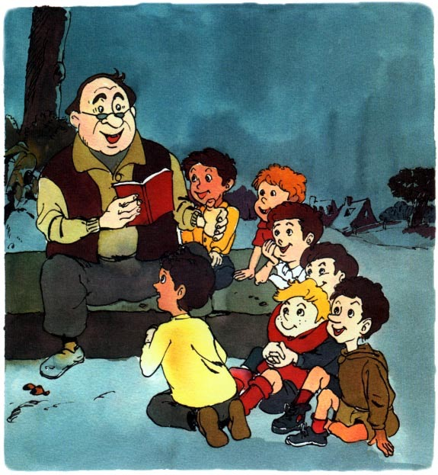

Respect other peoples belongings. People who have their money or things stolen will be very sad.

