Wk | Term 3
1 | Stories from the Buddha’s Life  Introduction
2 | The Wounded Swan  - Loving kindness, wisdom (DB/LB2)
3
4 | The Strings of the Lute  - Moderation (DB/LB12)
5
6 | The Golden Bowl  - Honesty (DB/JP6)
7
8 | The Tortoise who would Not Leave Home  - The Middle Way, Wisdom, Skill, Action (DB/JP10)
9
10 | Review – Stories from the Buddha’s Life

Stage Two: Term 3 Weekly Overview

VIEN GIAC TEMPLE- AUSTRALIA

Term Three: Stage 2 Lesson 1: Stories from The Buddha’s Life
Introduction
Lesson Sequence | Time | Lesson Aim: To introduce stories from Buddha’s life
Chanting | 10 min | - Recite name of Master Buddha-express respect and gratefulness to the Shakyamuni Buddha.  Nam Mô Shakyamuni Buddha (3 times),  - Breathing meditation –connect mind and body to the present.  Next breath in, breath out breath meditation (3 times),  - Chanting Amitabha- peaceful Buddha- lead to complete mindfulness,  followed by Chanting Amitabha student repeat after teacher (3 times)
Questioning  and Discussion | 5min | - Ask children to remember some stories they have heard about Buddha’s life.  - Ask some students to briefly share a few key points of a story they remember with the rest of the class.
Lesson Activity | 5min | Teacher will listen to the student’s stories  Teacher will guide the students in revisiting the correct information in the stories presented.  Teacher will choose one story mentioned by the students and retell the story to the students in more detail.
Student Activity | 5min | Students will be placed in pairs  They will then retell the story just told by the teacher to their partner.

VIEN GIAC TEMPLE- AUSTRALIA

Term Three: Stage 2 Lesson 2: The Wounded Swan
Lesson Sequence | Time | Lesson Aim: To highlight the values of compassion and kindness towards all living things.  Resources: Sequencing worksheet; The wounded Swan
Chanting | 10 min | - Recite name of Master Buddha-express respect and gratefulness to the Shakyamuni Buddha.  Nam Mô Shakyamuni Buddha (3 times),  - Breathing meditation –connect mind and body to the present.  Next breath in, breath out breath meditation (3 times),  - Chanting Amitabha- peaceful Buddha- lead to complete mindfulness,  followed by Chanting Amitabha student repeat after teacher (3 times)
Story | 5min | The Wounded Swan  1. Devadatta is the cousin of Prince Siddhartha, together they were walking in the woods one day, and they noticed a swan. Devadatta quickly drew his bow and arrow, he aimed at the swan and shot it. Prince Siddhartha ran to the wounded swan and quickly pulled out the arrow. He held the injured swan in his arms and stroked it.  2. Devadatta became angry, he shouted at Prince Siddhartha to give him the swan because he shot it and so belonged to him.  3. The prince refused to give the swan to Devadatta as he feared that Devadatta would kill it. Prince Siddhartha decided to ask the ministers of the court and to let them decide the fate of the swan."  4. The ministers all had different opinions. Some of them thought Devadatta should keep the swan. Others thought the swan should go to Prince Siddhartha. One wise minister said, "A life belongs to the one who saves it, not to the one who will destroy it. The ministers ruled that the swan would go to Prince Siddhartha."  5. Prince Siddhartha nursed the swan back to health and helped heal it’s wound. Once it could fly again, he returned it to the woods where it could live freely with its own kind.
Questioning  and Discussion | 5min | Ask students to recall the story in the correct order of events.  What happened in the story first, next and final?  Why did Prince Siddhartha want to keep the swan?
Student Activity | 5min | Students will sequence text into the correct order.

VIEN GIAC TEMPLE- AUSTRALIA

Term Three: Stage 2 Activity 2: The Wounded Swan

Place a number 1 to 5 in the correct box to put the information in the correct order. The first one is done for you.
 | The prince refused to give the swan to Devadatta, as he feared that Devadatta would kill it. Prince Siddhartha decided to ask the ministers of the court and to let them decide the fate of the swan."
 | Devadatta became angry, he shouted at Prince Siddhartha to give him the swan because he shot it and so belonged to him.
 | Prince Siddhartha nursed the swan back to health and helped heal its wound. Once it could fly again, he returned it to the woods where it could live freely with its own kind.
1. | Devadatta is the cousin of Prince Siddhartha, together they were walking in the woods one day, and they noticed a swan. Devadatta quickly drew his bow and arrow, he aimed at the swan and shot it. Prince Siddhartha ran to the wounded swan and quickly pulled out the arrow. He held the injured swan in his arms and stroked it.
 | The ministers all had different opinions. Some of them thought Devadatta should keep the swan. Others thought the swan should go to Prince Siddhartha. One wise minister said, "A life belongs to the one who saves it, not to one who will destroy it. The ministers ruled that the swan would go to Prince Siddhartha."

VIEN GIAC TEMPLE- AUSTRALIA

Term Three: Stage 2 Lesson 3: The Wounded Swan
Lesson Sequence | Time | Lesson Aim: To highlight the values of compassion and kindness towards all living things.  Resources: The wounded Swan picture.
Chanting | 10 min | - Recite name of Master Buddha-express respect and gratefulness to the Shakyamuni Buddha.  Nam Mô Shakyamuni Buddha (3 times),  - Breathing meditation –connect mind and body to the present.  Next breath in, breath out breath meditation (3 times),  - Chanting Amitabha- peaceful Buddha- lead to complete mindfulness,  followed by Chanting Amitabha student repeat after teacher (3 times)
Story | 5min | The Wounded Swan  1. Devadatta is the cousin of Prince Siddhartha, together they were walking in the woods one day, and they noticed a swan. Devadatta quickly drew his bow and arrow, he aimed at the swan and shot it. Prince Siddhartha ran to the wounded swan and quickly pulled out the arrow. He held the injured swan in his arms and stroked it.  2. Devadatta became angry, he shouted at Prince Siddhartha to give him the swan because he shot it and so belonged to him.  3. The prince refused to give the swan to Devadatta as he feared that Devadatta would kill it. Prince Siddhartha decided to ask the ministers of the court and to let them decide the fate of the swan."  4. The ministers all had different opinions. Some of them thought Devadatta should keep the swan. Others thought the swan should go to Prince Siddhartha. One wise minister said, "A life belongs to the one who saves it, not to the one who will destroy it. The ministers ruled that the swan would go to Prince Siddhartha."  5. Prince Siddhartha nursed the swan back to health and helped heal it’s wound. Once it could fly again, he returned it to the woods where it could live freely with its own kind.
Questioning  and Discussion | 5min | Why is it important to be kind and to have compassions to all living beings including animals?  (like us, all animals have a fear of death and have a desire to live, therefore we must be kind, compassionate and value their life as we do for ourselves).
Student Activity | 5min | Students will write a sentence about being kind.

VIEN GIAC TEMPLE- AUSTRALIA

Term Three: Stage 2 Activity 3: The Wounded Swan
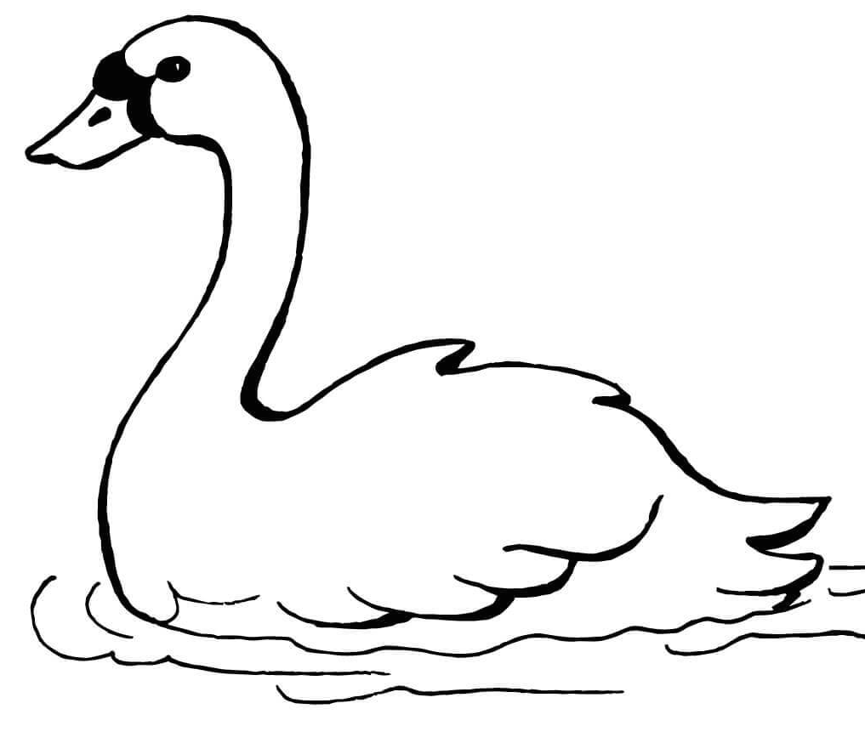
Why should we kind and compassionate to all living things?

We should be kind to all living beings because____________________________________________________________________________________________________________________

VIEN GIAC TEMPLE- AUSTRALIA

Term Three: Stage 2 Lesson 4: The Strings of the Lute (The Middle Path)
Lesson Sequence | Time | Lesson Aim: To understand that doing things in moderation is the healthiest option for our body and mind.  Resources: The Strings of the Lute worksheet- Finding the Balance
Chanting | 10 min | - Recite name of Master Buddha-express respect and gratefulness to the Shakyamuni Buddha.  Nam Mô Shakyamuni Buddha (3 times),  - Breathing meditation –connect mind and body to the present.  Next breath in, breath out breath meditation (3 times),  - Chanting Amitabha- peaceful Buddha- lead to complete mindfulness,  followed by Chanting Amitabha student repeat after teacher (3 times)
Story | 5min | The strings of the Lute  Sona is one of Buddha's disciples, and he wanted to be the best monk and the best meditator. Because he tried so hard, he became exhausted, he was disappointed in himself and wanted to give up.  Sakyamuni Buddha understood Sona’s problem, and he knew that before Sona was a monk, he was a musician. The Buddha decided to lead Sona to see the problem for himself.  Buddha showed Sona the very tight string on a lute and asked if this perfectly tight sting would produce the most beautiful sound?  Sona explained to the Buddha that the tight string makes an unpleasant sound and the string could break easily.  Buddha then asked Sona if a loose string would be better.  Sona then explained with confidence that a loose string does not make a pleasant sound either. The strings on a lute shouldn’t be too tight or too loose to make beautiful music.  At this point, Sona suddenly realised the Buddha was teaching him not to be too hard on himself, but at the same time, he needed to work to the best of his ability.  Like the strings of the lute if we work too hard, we will break, and if we don't work hard enough, we don't succeed.
Questioning  and Discussion | 5min | Why did Sona want to give up on being a monk?  (because he was trying too hard and became exhausted).  What could he have done differently?  (He should slow down,be patient and find the best balance).
Student Activity | 5min | Students will show on a scale of 1- 10, their balance in participating in various activities and identify that the middle path is best.

VIEN GIAC TEMPLE- AUSTRALIA

Term Three: Stage 2 Activity 4: The Lute Strings (Middle Path)

Finding the Balance

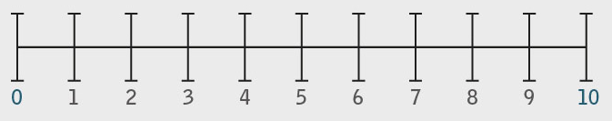
Shade the box on the scale of 1 to 10 of what the best balance is for you.

1. I was given a giant size block of chocolate, I should:

2. My parents are very tired from working all day, I should:

3. When watching TV: I should:

In your answers above, which boxes did you shade on the scale?
Watch TV 24 hours a day
Watch a little bit of TV each day.
Watch no TV
Make sure my room is tidy and I help as much as I can.
Clean the whole house by myself until I am so tired.
Not help them with the housework.
Eat a little bit of chocolate and share the rest.
Eat an entire block of chocolate till I get sick.
Eat no
Chocolate
HIGH
MIDDLE
LOW
VIEN GIAC TEMPLE- AUSTRALIA

Lesson Sequence | Time | Lesson Aim: To understand that doing things in moderation is the healthiest option for our body and mind and to introduce The Middle Path.  Resources: Worksheet, Draw and label an activity.
Chanting | 10 min | - Recite name of Master Buddha-express respect and gratefulness to the Shakyamuni Buddha.  Nam Mô Shakyamuni Buddha (3 times),  - Breathing meditation –connect mind and body to the present.  Next breath in, breath out breath meditation (3 times),  - Chanting Amitabha- peaceful Buddha- lead to complete mindfulness,  followed by Chanting Amitabha student repeat after teacher (3 times)
Questioning  and Discussion | 5min | - Teacher will ask students to remember the previous lesson about the strings of the lute.  - Recall the scales of 1-10 of finding the balance for ones-self.  - Say to the students that today they will be learning more about The Middle Path.
Lesson Information | 5min | The Lute Strings (The Middle Path)  Following The Middle path has to do with finding the right balance for your thoughts and actions.  We used the example of the three strings of the lute to show the Middle Path. The Buddha had a disciple by the name of Sona who practiced meditation so extremely that he could not advance in his meditation.  He made himself so tired that he wanted to give up on life as a monk. The Buddha knew his problem and used the strings on the lute to show him an example of working too hard and not hard enough.  Buddha reminded Sona that he needed to find the middle path of his thoughts and actions so that he can find the right balance to succeed.
Student Activity | 5min | Students will draw a picture and label an activity, which they must find the Middle Path for in order to help them be happy.  For example: I will play on my PlayStation sometimes, so that I have more  time with my family.

Term Three: Stage 2 Lesson 5: The Lute Strings (Middle Path continued)
VIEN GIAC TEMPLE- AUSTRALIA

Term Three: Stage 2 Activity 5: The Lute Strings (Middle Path continued)

Draw and label an activity that you need to find the middle Path in.

My activity is:

________________________________________________________

VIEN GIAC TEMPLE- AUSTRALIA

Term Three: Stage 2 Lesson 6: The Golden Bowl
Lesson Sequence | Time | Lesson Aim: To understand that honesty has it’s rewards.  Resources: The Golden Bowl activity.
Chanting | 10 min | - Recite name of Master Buddha-express respect and gratefulness to the Shakyamuni Buddha.  Nam Mô Shakyamuni Buddha (3 times),  - Breathing meditation –connect mind and body to the present.  Next breath in, breath out breath meditation (3 times),  - Chanting Amitabha- peaceful Buddha- lead to complete mindfulness,  followed by Chanting Amitabha student repeat after teacher (3 times)
 | 5min | The Golden Bowl  Many years ago, in ancient India, there were two sellers who would go from door to door, selling pots and pans. One was an honest seller and the other one was greedy. The greedy seller came to the door of a very poor family. He showed a girl and her grandmother beautiful items. The girl begged her grandmother to buy a pretty cup. But they could not afford it and wanted to offer something in exchange. They found an old bowl and offered it to the seller in exchange for a pretty cup. The seller immediately knew that the bowl was gold and it was worth a fortune! He also knew that the girl and her grandmother had no idea of it's worth. He played a trick on them and told them it was worth nothing. He wanted to come back later to take it from them for free.  Later that day the other seller came to the grandmother's door. He was polite and had a gentle manner. Once again the girl begged her grandmother for a pretty cup. The grandmother saw that this seller was quite different from the other one and offered him the bowl. The honest seller knew straight away that it was gold. He told the grandmother the truth, that it was pure gold. The grandmother wanted him to have it for something little in return for her granddaughter. The honest seller gave her a generous amount of money and items in exchange for the bowl instead of something little. The grandmother and the girl happily accepted the offer. Now, they had enough money and goods to sell for their living. The honest seller was also pleased and headed off to the river to continue his journey.  The greedy seller came back to get the golden bowl, but it was already sold to the honest seller. The greedy seller was left with nothing and could not continue his journey.
Questioning  and Discussion | 5min | Why was the grandmother happy? (She sold her bowl to an honest seller and received more than she asked for).  Why was the honest seller happy? (He bought a golden bowl and was able to continue his journey).  Why was the greedy seller unhappy? (He lost the bowl and didn’t make money to continue his journey).
Student Activity | 5min | Students will match the correct text to the picture
VIEN GIAC TEMPLE- AUSTRALIA

O O
Draw a line to match the correct picture to the text.
0 0

I am happy because I sold my bowl to an honest person and I received a generous amount for it, even though I didn’t ask for much.
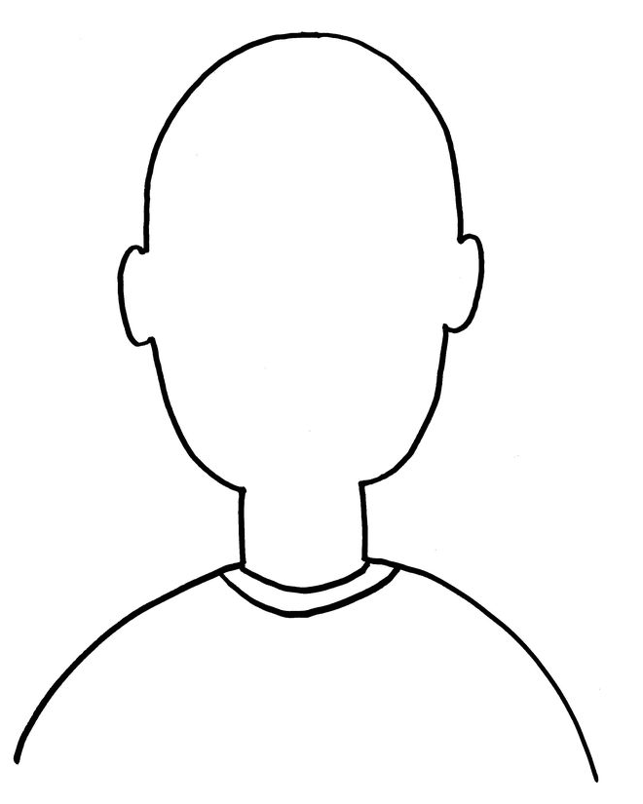

I am happy because I was honest and I got to continue my journey.

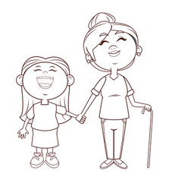
Term Three: Stage 2 Activity 6: The Golden Bowl
VIEN GIAC TEMPLE- AUSTRALIA

I am sad because I couldn’t afford to continue my journey because of my dishonesty.
Lesson Sequence | Time | Lesson Aim: To understand that honesty has its rewards.  Resources:
Chanting | 10 min | - Recite name of Master Buddha-express respect and gratefulness to the Shakyamuni Buddha.  Nam Mô Shakyamuni Buddha (3 times),  - Breathing meditation –connect mind and body to the present.  Next breath in, breath out breath meditation (3 times),  - Chanting Amitabha- peaceful Buddha- lead to complete mindfulness,  followed by Chanting Amitabha student repeat after teacher (3 times)
 | 5min | The Golden Bowl  Many years ago, in ancient India, there were two sellers who would go from door to door, selling pots and pans. One was an honest seller and the other one was greedy. The greedy seller came to the door of a very poor family. He showed a girl and her grandmother beautiful items. The girl begged her grandmother to buy a pretty cup. But they could not afford it and wanted to offer something in exchange. They found an old bowl and offered it to the seller in exchange for a pretty cup.The seller immediately knew that the bowl was gold and it was worth a fortune! He also knew that the girl and her grandmother had no idea of it's worth. He played a trick on them and told them it was worth nothing. He wanted to come back later to take it from them for free.  Later that day the other seller came to the grandmother's door. He was polite and had a gentle manner. Once again the girl begged her grandmother for a pretty cup. The grandmother saw that this seller was quite different from the other one and offered him the bowl. The honest seller knew straight away that it was gold. He told the grandmother the truth, that it was pure gold. The grandmother wanted him to have it for something little in return for her granddaughter. The honest seller gave her a generous amount of money and items in exchange for the bowl instead of something little. The grandmother and the girl happily accepted the offer. Now, they had enough money and goods to sell for their living. The honest seller was also pleased and headed off to the river to continue his journey.  The greedy seller came back to get the golden bowl, but it was already sold to the honest seller. The greedy seller was left with nothing and could not continue his journey.
Questioning  and Discussion | 5min | Discuss the concept of good things happening to good people.  Ask students about why it’s important to be honest.  Ask students to think about a time they were honest.
Student Activity | 5min | Students draw a picture of themselves show a time that they were honest.
Term Three: Stage 2 Lesson 7: The Golden Bowl (continued)

VIEN GIAC TEMPLE- AUSTRALIA

Term Three: Stage 2 Lesson 7: The Golden Bowl (continued)

Draw a picture of a time that you were honest

VIEN GIAC TEMPLE- AUSTRALIA

Term Three: Stage 2 Lesson 8: The Tortoise who would Not Leave Home
VIEN GIAC TEMPLE- AUSTRALIA
Lesson Sequence | Time | Lesson Aim: To understand that you cannot hold on to anything because everything changes.  Resources: The activity 8 worksheet
Chanting | 10 min | - Recite name of Master Buddha-express respect and gratefulness to the Shakyamuni Buddha.  Nam Mô Shakyamuni Buddha (3 times),  - Breathing meditation –connect mind and body to the present.  Next breath in, breath out breath meditation (3 times),  - Chanting Amitabha- peaceful Buddha- lead to complete mindfulness,  followed by Chanting Amitabha student repeat after teacher (3 times)
 | 5min | The  Tortoise who would Not Leave Home  Many years ago there was a tortoise that lived in a big lake that was close to a big river. When it rained heavy, the lake and the river joined together, but when the season was dry and water was low, the lake and river separated.  When the fish and tortoises sensed a dry year, they would swim out of the lake and into the river. But there was one tortoise that would not leave the lake to go to the river. Although the other tortoises were swimming to the river with a drought approaching, this tortoise would not move because it was his home.  When the lake began to dry, the tortoise buried himself in the mud. During that summer a man came down to the lake to dig for clay. He dug with his spade into the clay where the tortoise was laying. He accidently hit it. He saw that the tortoise was in pain and it was dying in that spot because it did not want to leave it’s home.  The man realised how holding on firmly to anything was not wise. Because everything changes. Just as the clay goes from wet to dry and soft to hard, all things change and cannot be held onto forever.
Questioning  and Discussion | 5min | Why didn’t the tortoise want to leave?  (because he was holding onto his home).  Why should the tortoise have left?  (because the land he lived at was changing and he should have moved to safety).
Student Activity | 5min | The students will complete a maze activity to help the tortoise get from the lake to the river.

Term Three: Stage 2 Activity 8: The Tortoise who would Not Leave Home

Help the Tortoise find his way from the lake to the river where it is safe.

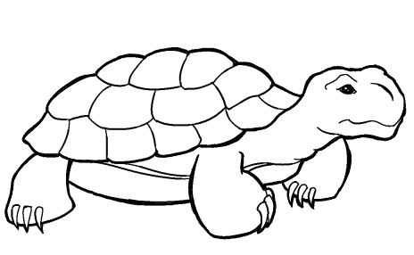
The Lake

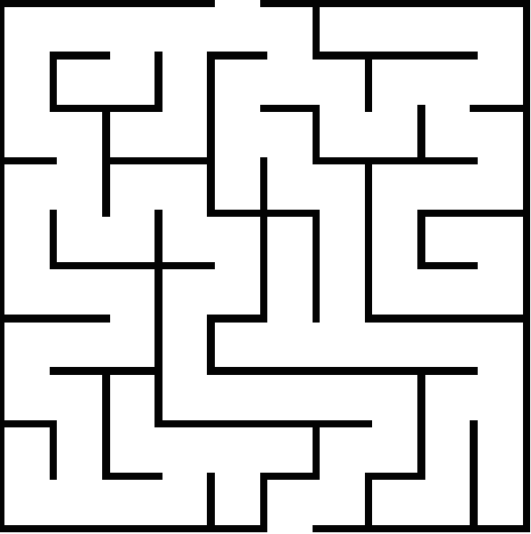

The river

VIEN GIAC TEMPLE- AUSTRALIA

Term Three: Stage 2 Lesson 9: The Tortoise who would Not Leave Home (continued)
Lesson Sequence | Time | Lesson Aim: To understand that you cannot hold on to anything because everything changes.  Resources: The activity 9 worksheet
Chanting | 10 min | - Recite name of Master Buddha-express respect and gratefulness to the Shakyamuni Buddha.  Nam Mô Shakyamuni Buddha (3 times),  - Breathing meditation –connect mind and body to the present.  Next breath in, breath out breath meditation (3 times),  - Chanting Amitabha- peaceful Buddha- lead to complete mindfulness,  followed by Chanting Amitabha student repeat after teacher (3 times)
 | 5min | The  Tortoise who would Not Leave Home (continued)  Many years ago there was a tortoise that lived in a big lake that was close to a big river. When it rained heavy, the lake and the river joined together, but when the season was dry and water was low, the lake and river separated.  When the fish and tortoises sensed a dry year, they would swim out of the lake and into the river. But there was one tortoise that would not leave the lake to go to the river. Although the other tortoises were swimming to the river with a drought approaching this tortoise would not move because it was his home.  When the lake began to dry, the tortoise buried himself in the mud. During that summer a man came down to the lake to dig for clay. He dug with his spade into the clay where the tortoise was laying. He accidently hit it. He saw that the tortoise was in pain and it was dying in that spot because it did not want to leave it’s home.  The man realised how holding on firmly to anything was not wise. Because everything changes. Just as the clay goes from wet to dry and soft to hard, all things change and cannot be held onto forever.
Questioning  and Discussion | 5min | What decision should the tortoise have made?  (He should have realised that his home was too dangerous and he should have moved to safety).
Student Activity | 5min | Students will identify what harm they will be doing to themselves if they do not let go of things that are no longer good for them.
VIEN GIAC TEMPLE- AUSTRALIA
Item | Harm
Old, worn out shoes
Broken glasses
Rotten apple

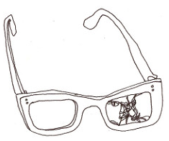
Term Three: Stage 2 Lesson 9: The Tortoise who would Not Leave Home (continued)
VIEN GIAC TEMPLE- AUSTRALIA

Write the correct answer in the box next to the picture.

Sore stomache

Sore feet

Sore eyes
What harm will you cause to your health if you keep these items

Term Three: Stage 2 Lesson 10: Review- Stories from the Buddha’s Life
Lesson Sequence | Time | Lesson Aim: To recall stories about Buddha’s life.  Resources: Bookmark and appreciation card cut-outs, printed onto white cardboard.
Chanting | 10 min | - Recite name of Master Buddha-express respect and gratefulness to the Shakyamuni Buddha.  Nam Mô Shakyamuni Buddha (3 times),  - Breathing meditation –connect mind and body to the present.  Next breath in, breath out breath meditation (3 times),  - Chanting Amitabha- peaceful Buddha- lead to complete mindfulness,  followed by Chanting Amitabha student repeat after teacher (3 times)
Lesson Information | 5min | Review- Stories from the Buddha’s Life  - Teacher will ask students to remember the stories that have been told over the last 9 weeks.  - Do a brief retelling of the student’s most favourite stories.  - Explain to the students that Buddha used stories to show examples of life experiences that are easy for us to relate to.  - Explain that these stories remind us to be mindful of our thoughts and actions.
Questioning  and Discussion | 5min | Ask students to remember someone who has been kind to them and to reflect on how that made them feel.
Student Activity | 5min | Students will make a book- mark and a card of appreciation for a special person for them to use when they read stories.

VIEN GIAC TEMPLE- AUSTRALIA

Term Three: Stage 2 Activity 10: Review- Stories from the Buddha’s Life

Show your gratitude to someone who has been kind to you by making a card and a bookmark for that person.

Cut out the bookmark

A kind gesture brings long lasting happiness to the person who gives and the person who receives.

Write the name of the person you wish to give the card to.

Dear _____________________,

I would like to thank you for doing something kind for me.

As a gesture of my appreciation,

I have made a bookmark for you.

I hope you like it.

With best wishes,

Sign your name and cut out the card.

VIEN GIAC TEMPLE- AUSTRALIA

